Multidimensional microclimate velocities alter the picture of shifting climates under forest canopies

Lydia G. Soifer1,2, James Ball1, Hamish Asmath3, Ilya M.D. Maclean4 & David Coomes1*

1 Department of Plant Sciences, University of Cambridge, UK

2 School of Natural Resources and Environment, University of Florida, USA

3 Department of Geography, University of the West Indies, St. Augustine, Trinidad and Tobago

4 Environment and Sustainability Institute, University of Exeter, UK

* Corresponding author email: [dac18@cam.ac.uk](mailto:dac18@cam.ac.uk)

# Abstract

Climate velocity describes expected speeds and directions at which species must move to track local climate change. Free-air climates, often used to calculate climate velocity, fail to represent climatic variation on land. We use a mechanistic microclimate model parameterized using macroclimate data and lidar-derived data of vegetation structure and topography to examine impacts of vegetative buffering on microclimate velocities in two- and three-dimensions across spatial scales from 20m to 1km within a tropical forest. Incorporating forest structure in the models reduced climate velocities across scales and produced maximum temperature velocity vectors pointed towards denser forest. When omitting forest structure, vectors shifted toward higher elevations. Three-dimensional climate velocities, which account for vertical temperature gradients within forests, further reduced speeds of expected shifts in distribution and produced velocity vectors directed from the canopy toward the understory. Microclimate variability, which reduced climate velocity, may therefore allow local population persistence in the face of climate change.

Climate change is causing the redistribution of species globally, with range shifts generally occurring toward higher latitudes and elevations1–3. Climate velocity indicates how quickly and in which direction suitable climatic conditions for species are shifting locally4,5 and estimates the distance per year a species occurring at any given location would have to move to keep pace with climate change4,5. Range shifts often lag behind rates of climate velocity or occur in directions opposing dominant climate gradients, suggesting species are unable to migrate fast enough to keep pace with the effects of global warming2,6–8. Yet analyses based on above-vegetation climate conditions4,5,9 overlook the role of climatic buffering by forest canopies, which may reduce velocities by providing microclimatic refugia10–13.

Forests are three-dimensional ecosystems where complex vegetative structures produce microclimatic variability, both horizontally along the forest floor and vertically within the canopy. By reducing solar radiation and airflow, tall, dense vegetation decouples understory climates from macroclimate conditions, generally decreasing maximum and increasing minimum temperatures14–16. Structurally complex forests are therefore characterized by a high degree of fine-scale spatial microclimatic heterogeneity defined largely by variability in canopy density and height12. These microclimates, which we define as local climate conditions within forests at a variety of spatial scales, influence the distribution of terrestrial and arboreal species12,16,18. As the climate warms, species may move along microclimate gradients produced by vegetation to maintain their thermal niche. Yet the scale at which vegetative structure and microclimatic heterogeneity impacts species movement depends largely on the size of the organism, varying from several centimeters to hundreds of meters19,20. Though using climate data representing climatic conditions that are both proximal to a species habitat, whether that be the understory or upper canopy, and that are at a biologically relevant spatial scale improve predictions of biological responses to climate change11,21, a paucity of microclimate data at large spatiotemporal extents has limited our capacity to quantify the impact of microclimatic variability on climate velocity in forested ecosystems.

Building upon previous research addressing free-air climate velocities4,5,22,23, we reexamine the speed and direction of microclimate velocities in two-dimensions in forest understories and three-dimensions within the canopy in comparison to free-air velocities across spatial scales.

To evaluate the impact of vegetative buffering and spatial scale on climate velocities, we use recent advances in mechanistic microclimate modeling24 to predict microclimates in two- and three- dimensions in the tropical forests of the Northern Range of Trinidad (Figure **1**). The microclimate model uses the physical laws of thermodynamics to connect macroclimate data to local microclimate conditions based on the impacts of topography and vegetation on solar radiation and wind speed. This mechanistic approach allows microclimate conditions to be modeled at fine spatial scales and at designated heights above ground over large spatial extents in areas, such as the tropics, that largely lack networks of in-situ microclimate sensors25. We first modeled land surface climates at 2 m above the ground at a 20 x 20 m resolution and within 20 x 20 x 5 m voxels from the ground to the top of the canopy for the years 1960 and 2015 (see methods; Supplementary figs. **1**, **2**). These microclimate models24 integrate ERA5 macroclimate data26 with a digital elevation model (DEM), canopy height model (CHM), and map of the vertical distribution of plant area density, all derived from a 1100 km2 2014 airborne lidar survey of the Northern Range of Trinidad, which spans 900 m in elevation. Though changes in vegetation cover over time may reduce the accuracy of microclimate predictions for 1960, we assume that the vegetation structure depicted in the 2014 survey represents vegetation structure across the 55-year time frame, because repeat lidar surveys were not available. From these models, we obtained maps of average maximum daily temperatures and minimum temperature of the coldest month, as climate extremes have a greater impact on species recruitment and survival than climate means27–29. We then coarsened microclimate maps by aggregating and averaging temperatures across grid cells to obtain maximum and minimum temperature estimates at 100 m and 1 km spatial resolutions.

We calculated maximum and minimum temperature velocities at all three spatial scales in two-dimensions across the land surface and in the top quarter of the canopy and advance microclimate research by extending the algorithm to calculate velocities in three-dimensions within forest canopies. Land surface microclimate velocities represent the distance and direction that a ground-dwelling species at any given location would need to move locally to remain within similar climatic conditions as the climate warms, while 3D velocities represent movement of local climate gradients experienced by arboreal species. We restrict 3D microclimate velocities to the upper half of the forest as measured from the ground to the canopy, because species occupying lower canopy positions have little vertical distance over which they can move.

To examine impacts of vegetation on climate velocities independently of spatial scale, we compare land surface and within-canopy velocities to free-air velocities over the same time period at ~1 km and 100 m resolutions. 1 km free-air velocities were calculated from CHELSA climate data30,31. 100 m free-air climate models were made by mechanistically downscaling ERA5 climate data with a 100 m DEM, produced by aggregating and averaging grid cells of the 20 m DEM, and represent free-air climate conditions that account for impacts of topography but not vegetation on climatic variability. While we focus on tropical rainforests due to the threats they face from novel high temperatures32 and the abundance of arboreal species that could be impacted by 3D climatic variability, the mechanistic nature of the climate models and velocity calculations allows our results to be applied globally to improve our understanding of impacts of vegetative buffering on climate velocity across spatial scales.

# Microclimatic heterogeneity reduces climate velocity

Despite the buffering capacity of vegetation, novel temperatures are occurring pantropically32, necessitating range shifts if species are to remain within their historical thermal niches. In the Northern Range of Trinidad between 1960 and 2015, free-air maximum and minimum temperatures warmed on average 0.51°C and 0.54°C, respectively (Extended Data Fig. **1**; Supplementary Fig. **3**, **4**). Our results indicate that accounting for the effects of forest canopies on understory climates reduces climate velocities for maximum and minimum temperatures across spatial scales by increasing spatial climatic heterogeneity (the denominator of the climate velocity equation) (Fig. **2**; Extended Data Figs. **2**-**4**; Supplementary Figs. **3**-**6**). At a 1 km resolution, maximum temperature velocities, which had a median of 25.6 m/yr, declined by only 2.1 m/yr, while minimum temperature velocities (median 27.8 m/yr) declined nearly three-fold (Fig. **2**; Extended Data Table **1**). The impacts of vegetative buffering were greater at a 100 m resolution, with over five-fold declines in maximum and minimum temperature velocities from 19.1 m/yr and 9.3 m/yr for free-air velocities to 5.49 m/yr and 1.20 m/yr for land surface velocities, respectively. Over 55 years, these decreases in velocity reduce the distance that maximum and minimum temperature isotherms shift from 1.05 km and 0.5 km to just 302 m and 66 m at a 100 m resolution. 3D velocities decline further across spatial scales, with medians below 1 m/yr. Slower microclimate velocities suggest changes in range dynamics will be slower than predicted by free-air conditions, consistent with lags in thermophilization when only free-air temperatures are considered33,34.

Within forests, species respond to climatic conditions at a variety of spatial scales depending on the size of the organism20,35. Due to the inverse relationship between spatial grain and climatic heterogeneity, relatively coarser resolutions increase climate velocity by reducing climatic variation, while finer resolutions decrease climate velocity by increasing climatic variation9,23,35. Smaller differences in free-air and land surface temperature velocities at a 1 km scale (Fig. **2**; Extended Data Table **1**) suggest range dynamics of larger species in tropical montane forests would have to shift at a similar rate to those estimated by free-air climate conditions to keep pace with climate change. However, differences between free-air and land surface velocities may increase in topographically homogeneous areas, such as tropical lowlands, where low free-air thermal variation increases climate velocities5. As the spatial resolution of analysis increases, greater spatial climatic heterogeneity reduces climate velocities to 5.49 m/yr and 1.20 m/yr at a 100 m resolution and to just 1.87 m/yr and 0.322 m/yr for maximum and minimum temperatures at a 20 m resolution across the land surface9,23 (Fig. **2**; Extended Data Fig. **2**). Species, such as herbaceous plants, insects, and frogs, responding to climate at fine spatial scales may thus be able to persist locally by moving short distances within thermally variable environments, as long as they are not already restricted to the coolest microhabitats in the region13. These short distance movements may better represent thermoregulatory behavior in response to temperature extremes than persistent range shifts. However, at warm range edges where populations are often restricted to cool microhabitats, local thermal variability will not enable persistence.

# Vegetative buffering alters the direction of climate velocity

Traditional views of species range shifts assume movement toward higher latitudes and elevations as species track their preferred thermal niche36. However empirical evidence challenges this notion2,7,8. For example, a recent study by Rubenstein et al.8 found that only 47% of documented range shifts align with these expectations, which may be attributed to numerous factors, including persistence in local microclimates12 or range shifts along thermal gradients that oppose latitudinal or elevational gradients13. To explore the impact of vegetation on the direction of climate velocity, we examined whether climate velocities were directed upslope or toward areas with denser vegetation using circular correlations37,38 between the angle of climate velocity in the latitude-longitude plane and the angle a species would need to move to reach higher elevations or denser vegetation. We then graphed the distribution of differences between the angle of climate velocity and the direction of higher elevation or denser vegetation to visualize these correlations (Fig. **3**).

The direction of free-air velocities for maximum and minimum temperatures were directed upslope, as expected, exhibiting strong positive correlations with the direction needed to reach higher elevations and not with the direction needed to reach denser vegetation (Figs. **3**, **4**; Extended Data Table **1**). Small differences between the direction of ambient-air climate velocities and the direction of higher elevations support the pervasive view that species will shift upslope in the tropics39.

At the same spatial resolutions, land surface velocities for maximum temperatures exhibited positive correlations with both the direction of higher elevations and the direction of denser vegetation (Figs. **3**, **4**; Extended Data Table **1**). Increasing the spatial scale of analysis to a 20 m resolution maintained positive correlations with denser vegetation, while the strength of the correlation with higher elevations declined. Maximum temperature velocities will have greater relevance to range dynamics at the warm range edge where novel high temperatures may exceed thermal tolerances. When dispersal capacity, biotic interactions, or life history traits prevent upslope range shifts at a pace matching that of climate change1,6,7, dense vegetation may thus provide climatic refugia by decoupling local climate from free-air conditions, akin to convergent environments, such as valley bottoms that support topoclimate refugia22. These microclimate refugia may thus slow range contraction and extirpation of heat-intolerant species, which is contributing to thermophilization of understory communities40. Species responding to fine scale climate gradients will thus depend on maintaining forests with complex vegetative structure where taller and denser patches offset maximum temperatures that may otherwise exceed the narrow critical thermal limits of tropical understory species41.

Land surface velocities for minimum temperatures were, in contrast, not correlated with the direction of denser vegetation at any spatial scale (Fig. **3**; Extended Data Table **1**), because minimum temperature offsets are often weak in tropical forest understories42,43 (Extended Data Fig. **5**). In temperate and boreal forests, minimum temperature offsets are more consistently positive, such that understories are warmer than free-air conditions42,43. Land surface velocities for minimum temperatures would thus be directed away from dense vegetation and toward cooler open habitats as the climate warms, representing the capacity for populations at cool range edges to expand their ranges and/or habitat use when minimum thermal constraints are relaxed.

In addition to temperature, species distributions are influenced by other climate variables, such as water availability, which together define the climate envelope of a species44. At macroclimate scales, misalignment between velocity vectors for temperature and precipitation could thus prevent species from maintaining their historical climatic niche and could lead to the reshuffling of ecological communities9,45. At microclimatic scales, mechanistic relationships between vegetation structure, temperature, relative humidity, and VPD will prevent substantial divergences in velocities that could negatively impact potential shifts in ranges or habitat use, because denser vegetation produces understory habitats that are cooler and wetter15–17. Thus, moving under dense vegetation to seek refuge from high maximum temperatures will simultaneously reduce hydric stress.

# 3D Climate Velocities

In tropical forests, arboreal species may be particularly susceptible to warming temperatures because forest canopies do not experience the same extent of thermal buffering as understories16,17,46. Indeed, the increase in temperature from the ground to the canopy can be up to 1.6 times the change in temperature across 200 m in elevation18. Slow 3D velocities present an additional spatial dimension along which species can shift to track warming climates. Over 85% of maximum temperature velocities across spatial scales were directed vertically downward in the montane forests of the Northern Range of Trinidad. In response to novel high temperatures, short distance movements vertically downward may thus offer refuge for some species. Indeed, vertical shifts in habitat use have been documented across short spatial and temporal gradients for arboreal frogs, which shift toward the ground at lower elevations and during the dry season, and for arboreal primates, which have increased their use of terrestrial habitat as temperatures have increased18,47,48.

However, downward shifts in temperature isotherms were not ubiquitous for either maximum or minimum temperatures. Maximum temperature velocities directed vertically upward often occurred in coastal areas with sparser vegetation, where vertical temperature gradients are reversed, such that air temperatures in the lower canopy are greater than air temperatures in the upper canopy17 (Extended Data Fig. **5**). Furthermore, only 52%, 67%, and 79% of minimum temperature velocity vectors exhibited downward movement at 20 m, 100 m, and 1 km spatial scales, respectively, due to weaker vertical gradients in minimum temperatures (Extended Data Fig. **5**). In temperate and boreal forests, where minimum temperature offsets are greatest, with higher minimum temperatures in the understory than in exposed habitats43, 3D minimum temperature velocity may be directed primarily upward as the climate warms. Regardless of direction, the vertical component of 3D velocity vectors was greater than the horizontal for both maximum and minimum temperatures. Vertical thermal gradients thus offer an important axis for thermoregulation under changing climatic conditions.

Yet, the full 3D forest environment is not available to all species. Resource distributions, including food and light limit vertical habitat availability for arboreal plants and animals. For example, low light in the lower canopy may prevent colonization by epiphytes, and predator-prey, mutualistic, and competitive interactions may prevent vertical reorganization of animal communities despite changing climates49. Furthermore, arboreal species have evolved mobility traits, such as flying and gliding locomotion and adhesive toe pads49, which may compromise their success in lower canopy or terrestrial environments where vegetation structure differs. If species are unable to extend their vertical habitat use, ranges could become vertically compressed into narrower canopy strata50. These processes have prevented marine plants from following vertical temperature velocities beyond the depth at which light attenuation limits photosynthesis50. After reaching the lower limit of suitable vertical habitat, arboreal species would be expected to move in the speed and direction of 2D velocities within the canopy (Supplementary methods). These canopy velocities for maximum temperatures exceed median land surface velocities by 39.1 m/yr and 5.93 m/yr at 1 km and 100 m resolutions, respectively, but do not exceed median land surface velocities at a 20 m resolution (Supplementary Table **1**; Supplementary Fig. **7**). If unable to move vertically downward, arboreal species responding to larger thermal gradients may thus have to move faster to keep pace with climate warming than terrestrial species.

# Conclusions

Accounting for impacts of vegetative buffering on understory microclimates reduces climate velocities and indicates that species may reduce exposure to warming temperatures by increasing their use of or becoming restricted to understory habitats beneath dense vegetation. Rather than approximating the distance species must move to keep pace with the rate of climate change, these microclimate velocities may thus better represent expected thermoregulatory behavior, particularly at fine spatial resolutions. The capacity to escape high temperatures by exploiting thermally complex landscapes will be critical for species with limited dispersal capacity as well as species living in landscapes with homogeneous macroclimate gradients, such as lowland tropical rainforests5,39. However, our analysis assumes constant vegetation structure due to a lack of repeat lidar surveys, which may underestimate velocities if canopy cover declines over time. Without changes in precipitation regimes, forests are expected to continue to offset temperatures, providing microrefugia for species43. Yet deforestation combined with tree mortality due to increasing disturbances from droughts, wildfires, and insect outbreaks are reducing canopy cover globally51,52. Vegetation declines could increase land surface and within-canopy climate velocities by increasing rates of microclimate warming53 and homogenizing microclimate variability if large tracts of forest are lost. Forest understory communities would thus be expected to exhibit faster rates of change relative to predictions made assuming constant vegetation structure34.

Monitoring impacts of forest change on microclimates will be critical to improve our understanding of climate velocities globally. NASA’s GEDI mission is beginning to make this possible by providing fine-resolution data on three-dimensional forest structure at a global extent54. Continued forest monitoring with the relaunch of the GEDI satellite presents an opportunity for temporally and spatially extensive microclimate modeling across the globe. Despite current data limitations, our results highlight the importance of maintaining and restoring structurally complex forests to reduce microclimate velocities relative to velocities in habitats more strongly coupled to free-air temperatures. Combining these models with empirical data on range shifts7 and habitat use will advance our understanding of climate change impacts on species globally.

# Online Methods

All analyses took place in the Northern Range of Trinidad, a Caribbean Island that lies off the coast of Venezuela, due to the availability of a wall-to-wall lidar survey of the island.

## Climate grids

We mechanistically modeled daily maximum temperature and minimum temperature of the coldest month for 1960 and 2015 accounting for impacts of topography and vegetation on understory and within-canopy temperatures at 1 km, 100 m, and 20 m resolutions using the R package ‘microclimf’24. Regardless of spatial resolution, we refer to these as microclimate models. Additionally, we modeled free-air temperatures at a 100 m spatial resolution, accounting for impacts of topography, but not vegetation, on climate using the R package ‘microclima’55. We chose the years 1960 and 2015 because they best represent average temperature during the decades 1951-1960 and 2011-2020. The climate models are based on first principles of energy conservation24. They first apply a topographic correction for adiabatic lapse rate and then estimate microclimate parameters by solving the Penmen-Monteith equation assuming the relationships between sensible heat fluxes and latent heat fluxes remain in balance. Microclimf has been validated against over 400 in situ temperature loggers spanning four continents in different land cover types, including 70 loggers in tropical rainforests, yielding more accurate predictions than other global climate models (e.g., Worldclim and ERA5)21,32. Microclimate models were initially produced at a 20 m spatial resolution. We chose a 20 m horizontal resolution based on a sensitivity analysis to determine a cell size that captured fine-scale variation in vegetation structure while minimizing outliers (Supplementary Methods). Microclimate models were produced at 2 m above the ground for land-surface climate estimates, and then from 5 m to 40 m above the ground at 5 m intervals (i.e. 2 m, 5 m, 10 m, etc.) to estimate within-canopy conditions (see supplementary methods for detailed description). We then coarsened the microclimate models to 100 m and 1 km resolutions by aggregating and averaging grid cells.

Model inputs included spatially gridded data describing macroclimate, topography, vegetation structure and characteristics, soil type, and habitat type. Gridded climate data were obtained from ERA526 using the ‘mcera5’ R package56 at an ~25 km resolution and at hourly time intervals for 1960 and 2015. Topography and vegetation layers were derived from discrete return Light Detection and Ranging (LiDAR) data, which was collected in June 2014. The consultant provided classifications for last return ground points and non-ground points, which were then kriged in ArcMap 10.5 to develop a digital elevation model (DEM) of ground points and a digital surface model (DSM) of non-ground points at a 1 m resolution. A canopy height model was developed by subtracting the DEM from the first-return non-ground points. The height of each point above the ground was computed in LASTools using the ‘lasheight’ function57. Plant area index (PAI; m2/m2) and plant area density (PAD; m2/m3) were calculated at a 20 m horizontal resolution and 1 m vertical resolution based on the Beer-Lambert law for light transmittance through a turbid medium and assuming an extinction coefficient of 0.558. We estimated PAI and PAD seasonality by modeling monthly fluctuations in MODIS LAI with a generalized additive mixed model and applying a standard offset across all months based on the difference in MODIS LAI and LiDAR PAI (see supplementary methods for further details).

We mapped soil type according to the USDA soil classification triangle with sand, silt, and clay content obtained from the SoilGrids database at a 250 m resolution59,60. We obtained habitat type data from a classification of Trinidadian vegetation61 and reclassified them to those specified in the ‘microclimf’ R package to estimate other vegetation parameters, including the ratio of vertical to horizontal leaf foliage, maximum stomatal conductance, leaf reflectance, canopy clumsiness, and leaf diameter24 (Supplementary Material).

To model microclimates in the Northern Range from remotely sensed data, we had to make assumptions that compromised model accuracy. First, the lack of repeat lidar surveys required that we assume constant vegetation over time. We also assume that soil and vegetation properties are constant within broad categories and concur with average parameters identified by the model.

For macroclimate velocity, we did not model climates and rather obtained climate data from CHELSA version 2.130,31 to represent a readily accessible macroclimate data source that could easily be used to calculate velocities across large spatial extents. Because CHELSA data were not available for 1960, we estimated the 1960 climate based on offsets between CHELSA and ERA5 data in 1980. Maximum daily temperatures and minimum temperatures of the coldest month for 1960 and 2015 were then averaged across months to produce a single raster for each year.

## Climate Velocity

Climate velocity is calculated as the temporal rate of climate change divided by the spatial rate of climate change4,5 ((dC/dt) / (dC/dx) = dx/dt). We calculated two-dimensional (land surface) and three-dimensional (within-canopy) microclimate velocities for daily maximum temperature (°C) and minimum temperature of the coldest month (°C) at three spatial scales — 1 km, 100 m, and 20 m resolutions. The vertical resolution of all 3D velocities was 5 m. We compared these microclimate velocities to two-dimensional free-air velocities at a 100 m resolution (calculated from free-air climate models) and at an ~1 km resolution (calculated from CHELSA data).

Climate velocity calculations were conducted in the R programming language62 adapting code from Garcia Molinos et al.63 (Supplementary methods). We calculated the temporal rate of climate change as the slope of temperature change between 1960 and 2015. The spatial rate of climate change represents the average temperature change in °C/m between neighboring grid cells. For each grid cell, the spatial rate in 2D is defined based on a 3 x 3 grid around the central cell. For each pair of adjacent cells, the temperature differences are calculated and divided by the distance between cell centers. Differences between cells that neighbor each other to the west and east were averaged to produce the x dimension of the spatial gradient, and differences between cells that neighbor each other to the north and south were averaged to produce the y dimension of the spatial gradient. When calculating averages, differences that did not include the focal cell were averaged by 1/ $\sqrt{2}$. The 2D spatial rate for each grid cell, *i*, is then calculated as $spatialrate_{i}=\sqrt{x_{i}^{2}+y_{i}^{2}}$ (Supplementary methods).

To calculate the 3D spatial rate of climate change, we took a similar approach, but made calculations based on adjacent voxels in a 3 x 3 x 3 cube (i.e., the central voxel and the 6 voxels that share a surface with the central one in the cube). We similarly calculated mean temperature differences in the x and y dimensions, but additionally calculated the differences between the central voxel and the voxel below it and the central voxel and the voxel above it. Vertical differences were divided by the height of each voxel (5 m) to obtain the ℃/m that temperature changes vertically. These vertical differences were averaged to produce the z dimension of the spatial rate of climate change. The 3D spatial rate of climate change for each voxel, *i*, is then calculated as $spatialrate_{i}=\sqrt{x_{i}^{2}+y_{i}^{2}+z_{i}^{2}}$. For 2D and 3D calculations at a 20 m resolution, we applied an elevational correction to account for the increase in distance that must be traveled if moving parallel to a slope (Supplementary methods).

To calculate climate velocity (m/yr), we took the absolute value of the temporal rate of climate change divided by the spatial rate of climate change. For 3D velocities, we only considered vectors that fell within the canopy, which we defined as falling between 50% and 100% of the relative height of the forest (where relative height is calculated as height of the climate velocity vector divided by canopy height). Additionally, we excluded vectors for microclimate and topoclimate velocities that exceeded the 95th quantile. These high values occur when the spatial rate of climate change is extremely small and do not accurately represent projected range shifts, particularly when temporal rates of climate change are relatively small.

The direction of climate velocity is the direction of the 2D or 3D vector describing the spatial rate of climate change. We calculated the direction of climate velocity in the latitude/longitude plane as the angle from north (i.e., 0 $​^{∘}$ = north, 180 $​^{∘}$ = south). For 3D velocities, we additionally calculated the vertical angle of movement from horizontal (where horizontal is parallel to the ground). The vertical angle ranges from -90 $​^{∘}$ to 90 $​^{∘}$, where -90° indicates that the velocity vector is pointed directly toward the ground with no horizontal movement, and 90° indicates the velocity vector is pointed directly up with no horizontal movement.

To determine whether climate velocities were directed upslope, we calculated the angular difference between the direction opposite to the aspect and the direction of climate velocity. To determine whether climate velocities were directed toward denser vegetation, we calculated the average direction of denser vegetation using the same method that we used to calculate the spatial rate of climate velocity. We then took the angular difference between the average direction of denser vegetation and the direction of climate velocity. We plotted angular differences using proportional histograms to show the proportion of grid cells where climate velocity is directed toward higher elevations or denser vegetation. An angular difference of 0 $​^{∘}$ indicates climate velocities are directed upslope or toward denser vegetation and a difference of 180 $​^{∘}$ indicates that climate velocities are directed downslope or toward sparser vegetation. Finally, we calculated the circular correlation between the direction of climate velocity and the direction of higher elevation or denser vegetation37,38.

# Figures

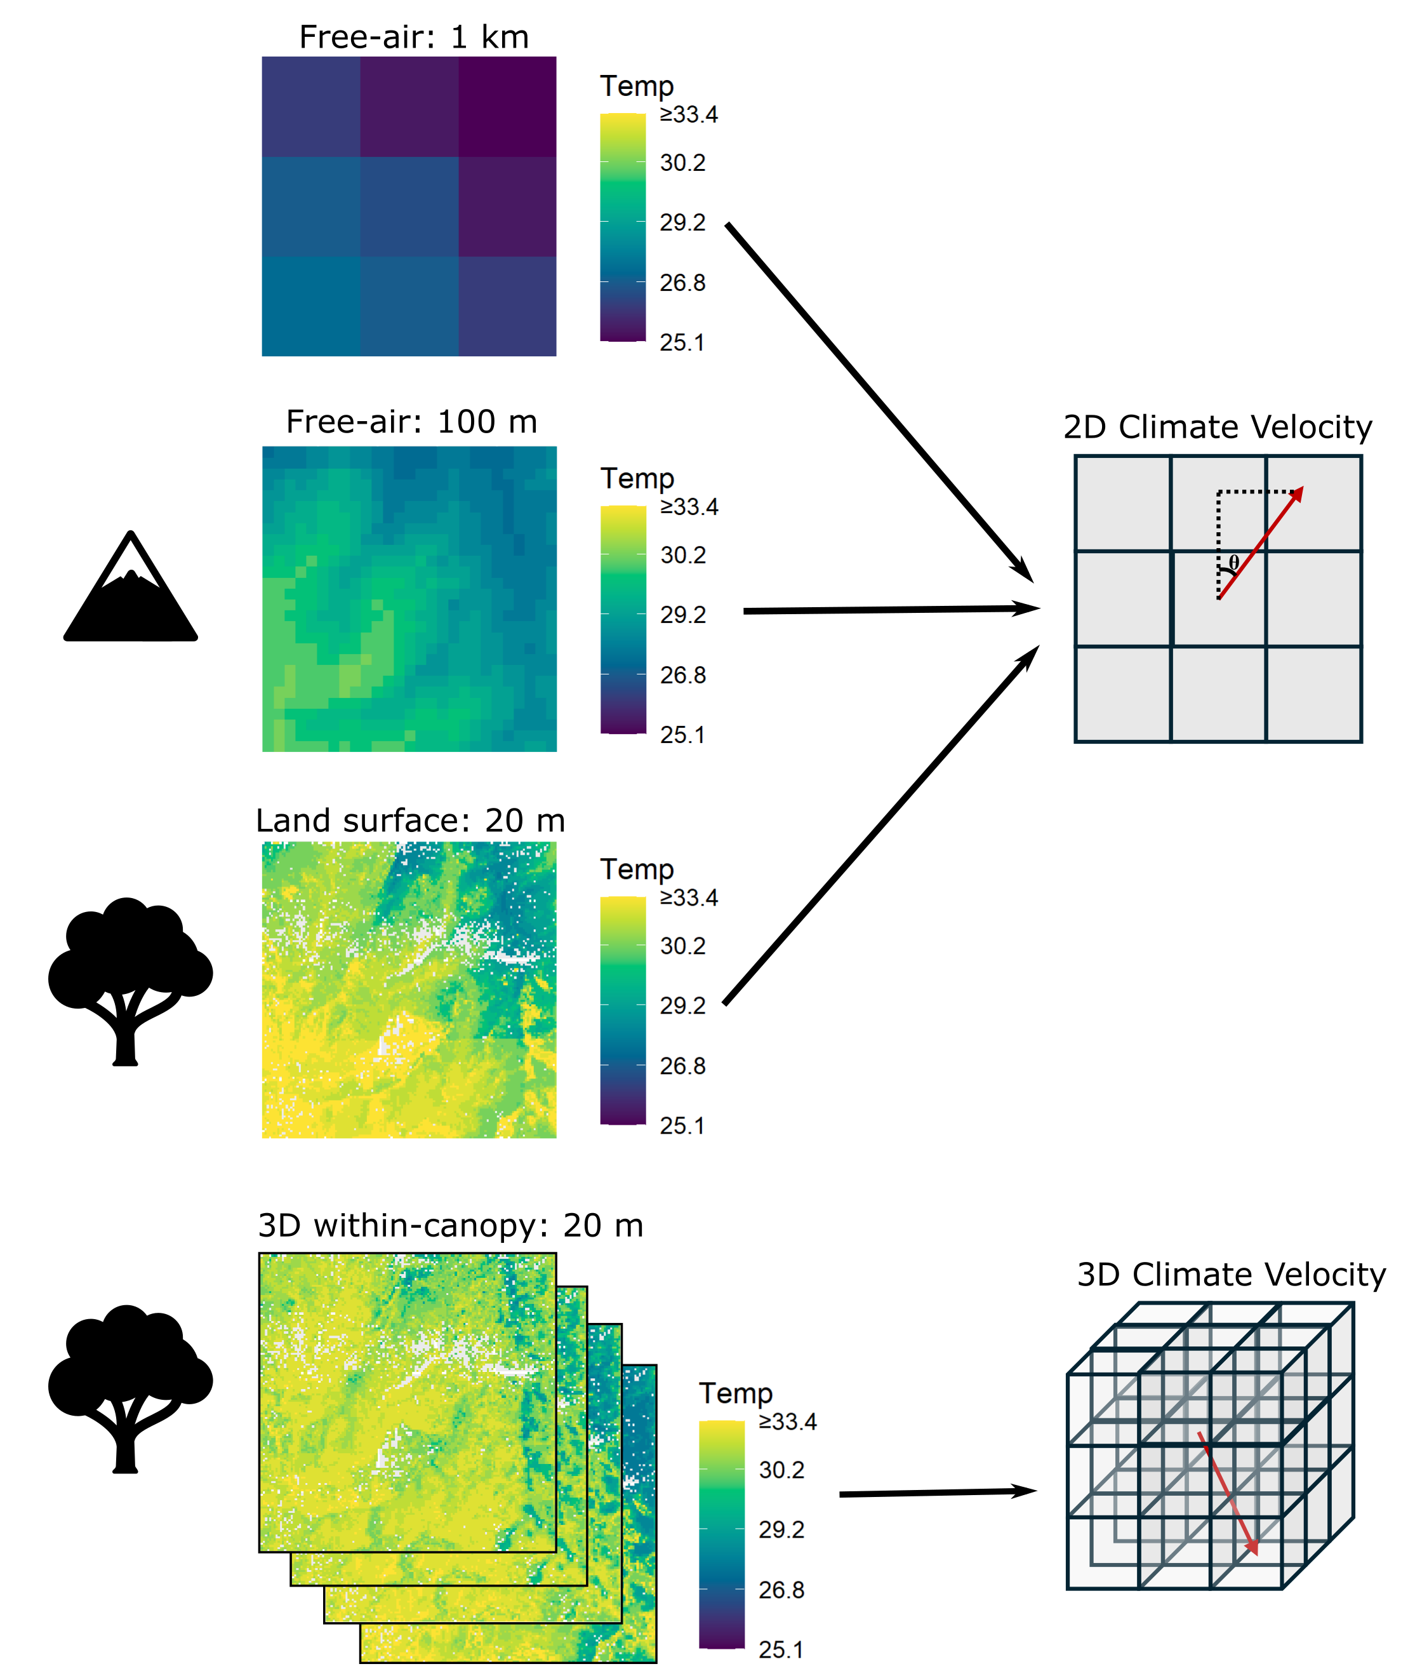

**Figure** **1:** Four spatial scales of temperature maps were used to estimate climate velocity. Free-air climate conditions at a ~1 km resolution were acquired from CHELSA climate data. Free-air climate conditions at a 100 m resolution were mechanistically modeled accounting for the impact of topography on climate. Microclimates were mechanistically modeled at a 20 m resolution accounting for impacts of topography and vegetation on climate. 2D land-surface microclimates represent climatic conditions at 2 m above the ground. 3D within-canopy microclimates represent climatic conditions at 5 m intervals from the ground to the top of the canopy. Climate velocity is represented by the red arrows. The length of the arrow represents the speed of climate velocity. For 2D climate velocities, the angle of the arrow from north (θ) represents the direction of climate velocity. For 3D microclimate velocities, the angle of the arrow from north represents the horizontal direction of velocity and the angle of the arrow from horizontal represents the vertical direction of velocity.

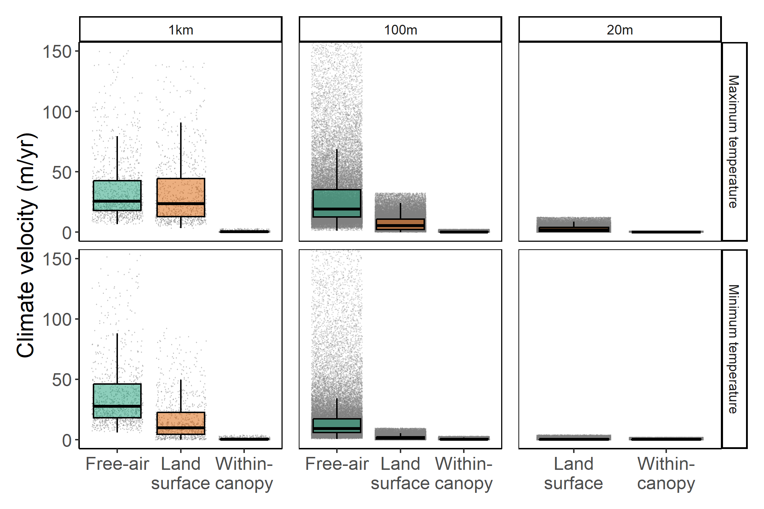

**Figure** **2:** The distribution of maximum and minimum temperature velocities (m/yr) in the Northern Range of Trinidad calculated at different spatial scales and using free-air, land-surface, or within-canopy temperatures. Free-air and land-surface velocities are calculated in two dimensions and within-canopy velocities are calculated in three-dimensions. Boxplots display median and 25th and 75th percentiles, with upper and lower whiskers corresponding to 1.5 times the IQR from the 25th or 75th percentiles. Free-air velocities were not calculated at a 20 m resolution. Gray points represent velocities at a maximum of 100,000 randomly selected points within the Northern Range. Though maximum free-air velocities at a 100 m resolution exceeded 150 m/yr, the y-axis is zoomed in so comparisons across scales were visible.

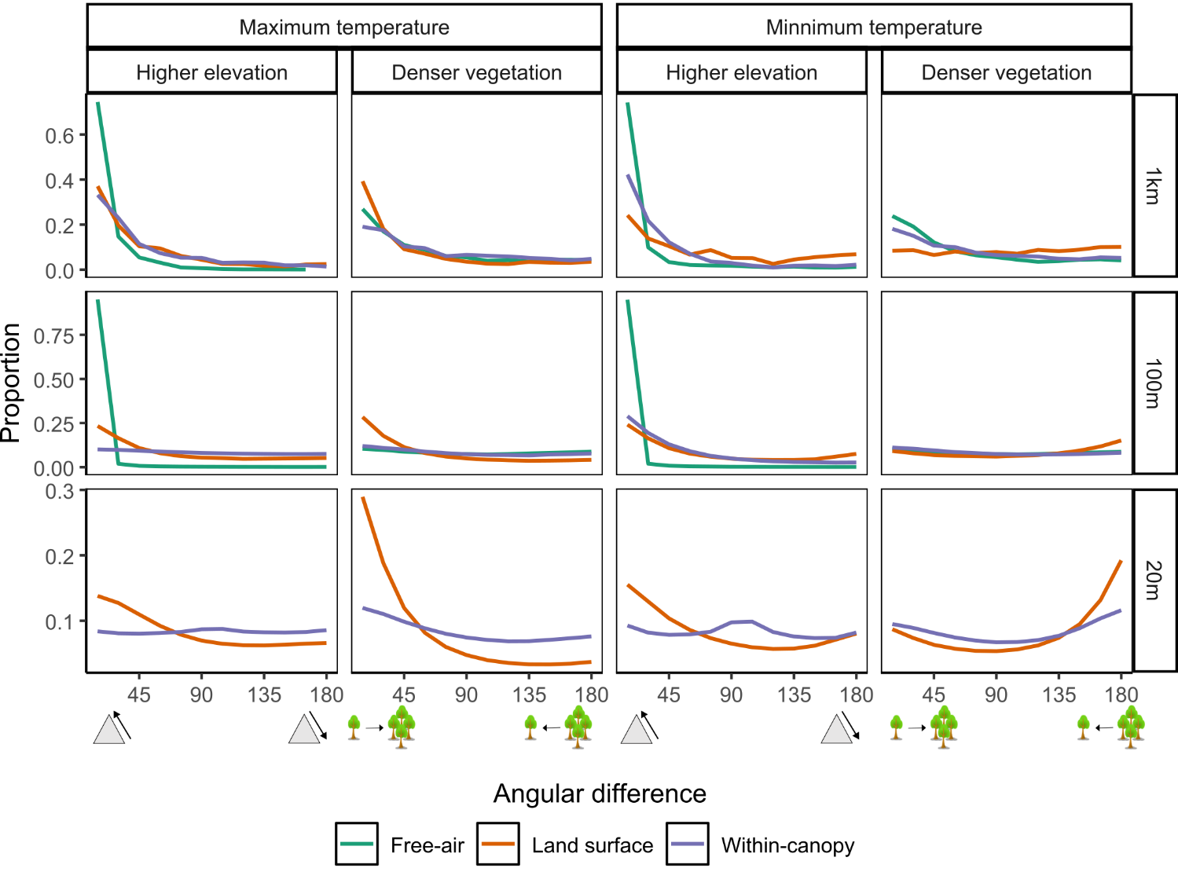

**Figure** **3:** Proportion of grid cells whose angular difference between the direction of maximum or minimum temperature velocity and the direction a species would need to move to reach a higher elevation or a denser vegetation. Proportions are calculated based on 15-degree intervals. An angular difference of zero indicates that the direction of climate velocity is pointed toward a higher elevation (i.e., upslope) or toward denser vegetation. An angular difference of 180 indicates that the direction of climate velocity is pointed downslope or away from denser vegetation. Land surface velocities are 2 m above the ground and within-canopy velocities are 3D velocities in the top half of the forest structure measured from the ground to the canopy.

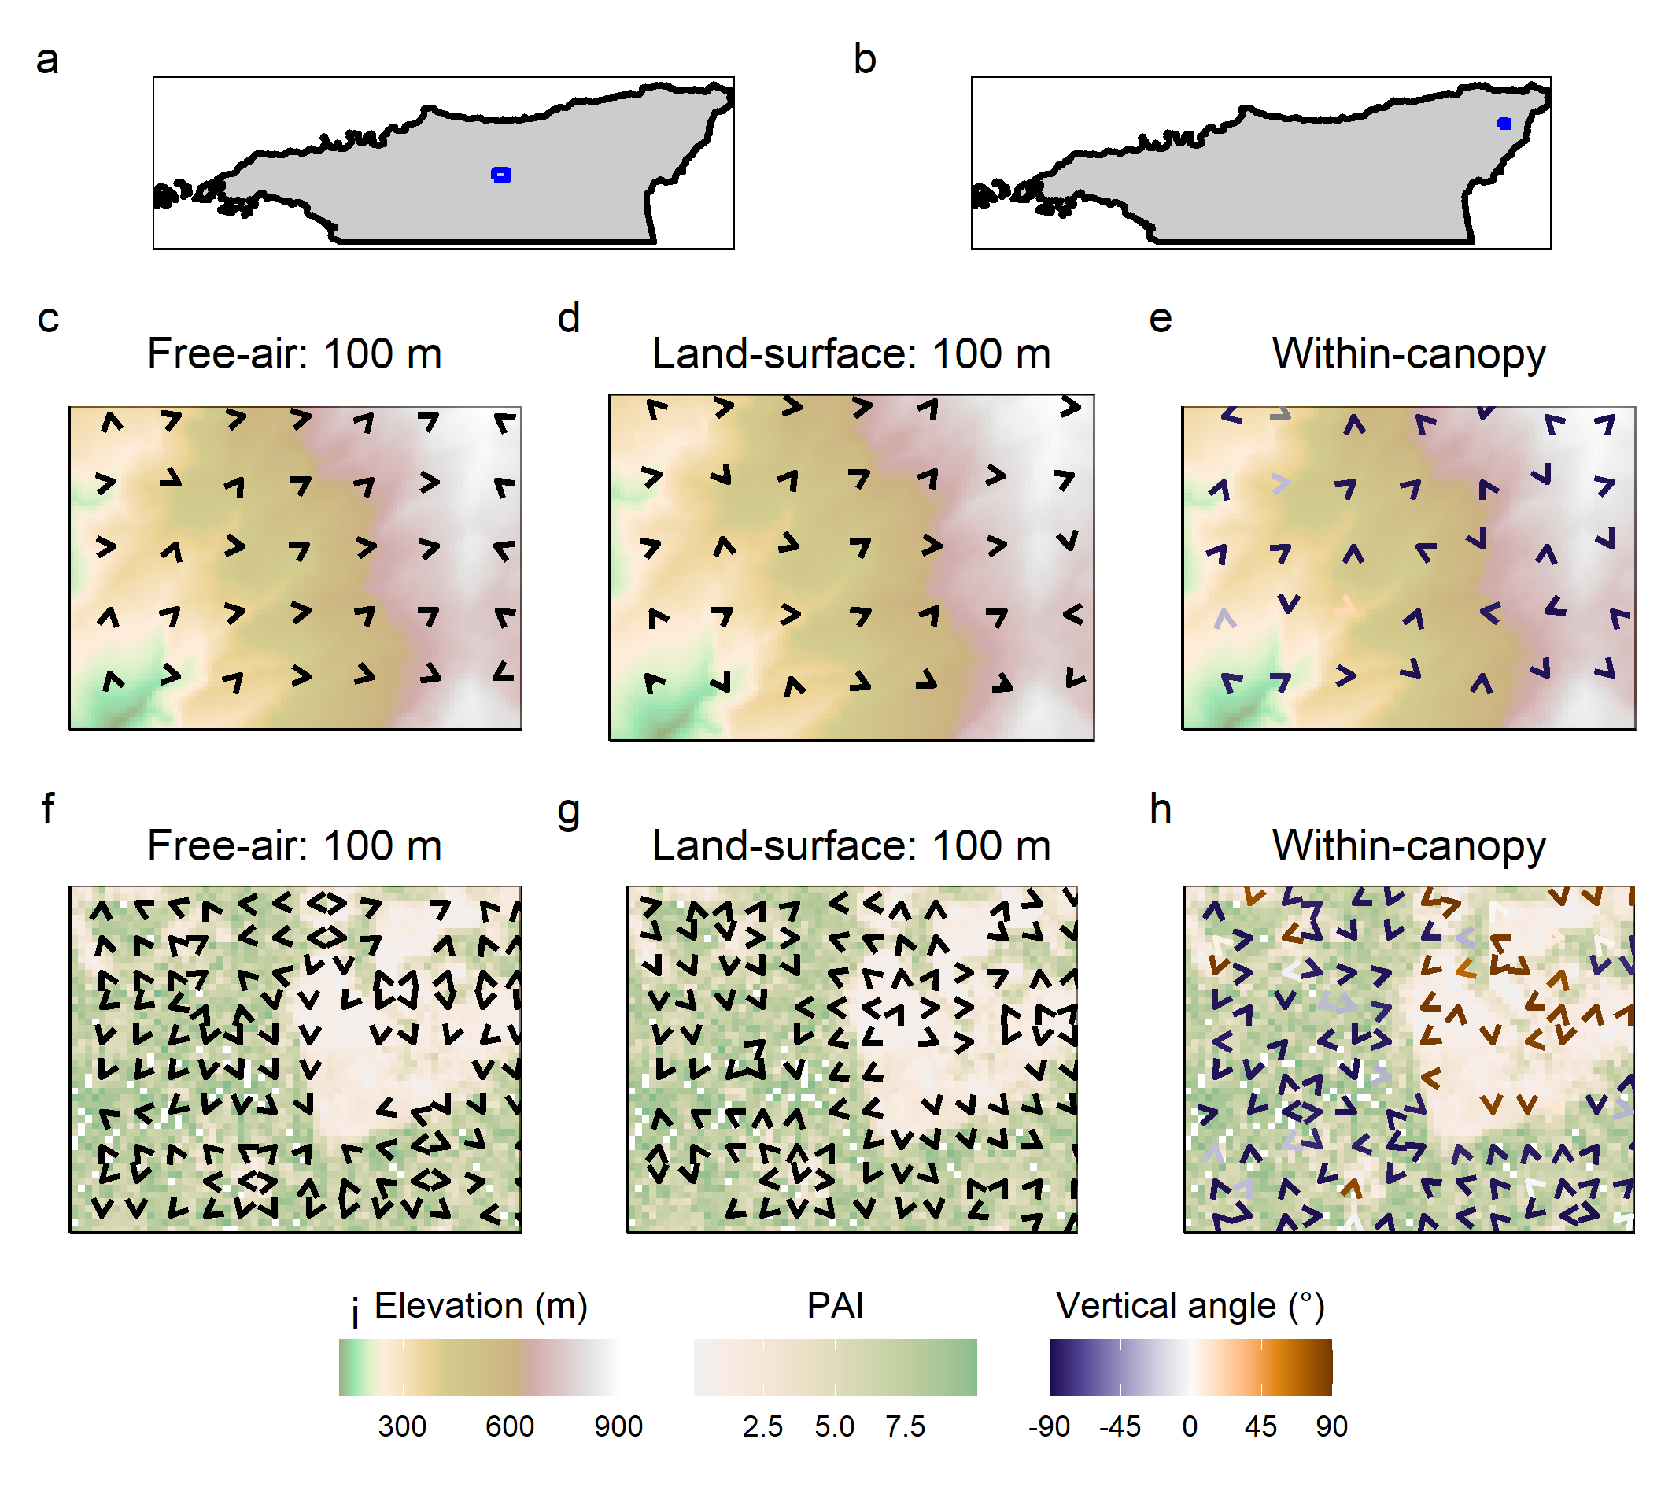

**Figure** **4:** The direction of maximum temperature velocity in two small areas in the northern range of Trinidad (a,b). (c-e) The direction of maximum temperature velocity for free-air, land-surface, and within-canopy velocities at a 100 m resolution plotted on top of elevation (area highlighted in panel a). Free-air velocities are primarily directed upslope, while land-surface and within-canopy velocities show no clear association with elevation. (f-h) The direction of maximum temperature velocity for free-air, land-surface, and within-canopy velocities at a 100 m resolution plotted on top of plant area index (PAI) (area highlighted in panel b). Land-surface velocities appear to be directed away from sparser vegetation, while free-air and within-canopy velocities show no clear association with PAI. (i) The vertical angle represents the angular direction from horizontal in which within-canopy 3D vectors are pointing. -90 indicates that vectors are pointed directly downward and 90 indicates that vectors are pointed directly upward.

# References

1. Chen, I.-C., Hill, J. K., Ohlemüller, R., Roy, D. B. & Thomas, C. D. [Rapid range shifts of species associated with high levels of climate warming](https://doi.org/10.1126/science.1206432). *Science* **333**, 1024–1026 (2011).

2. Lawlor, J. A. *et al.* [Mechanisms, detection and impacts of species redistributions under climate change](https://doi.org/10.1038/s43017-024-00527-z). *Nat Rev Earth Environ* **5**, 351–368 (2024).

3. Parmesan, C. & Yohe, G. [A globally coherent fingerprint of climate change impacts across natural systems](https://doi.org/10.1038/nature01286). *Nature* **421**, 37–42 (2003).

4. Burrows, M. T. *et al.* [The pace of shifting climate in marine and terrestrial ecosystems](https://doi.org/10.1126/science.1210288). *Science* **334**, 652–655 (2011).

5. Loarie, S. R. *et al.* [The velocity of climate change](https://doi.org/10.1038/nature08649). *Nature* **462**, 1052–1055 (2009).

6. Feeley, K. J. *et al.* [Upslope migration of Andean trees](https://doi.org/10.1111/j.1365-2699.2010.02444.x). *Journal of Biogeography* **38**, 783–791 (2011).

7. Lenoir, J. *et al.* [Species better track climate warming in the oceans than on land](https://doi.org/10.1038/s41559-020-1198-2). *Nat Ecol Evol* **4**, 1044–1059 (2020).

8. Rubenstein, M. A. *et al.* [Climate change and the global redistribution of biodiversity: Substantial variation in empirical support for expected range shifts](https://doi.org/10.1186/s13750-023-00296-0). *Environmental Evidence* **12**, 7 (2023).

9. Dobrowski, S. Z. *et al.* [The climate velocity of the contiguous United States during the 20th century](https://doi.org/10.1111/gcb.12026). *Global Change Biology* **19**, 241–251 (2013).

10. Haesen, S. *et al.* [Microclimate reveals the true thermal niche of forest plant species](https://doi.org/10.1111/ele.14312). *Ecology Letters* **26**, 2043–2055 (2023).

11. Lembrechts, J. J., Nijs, I. & Lenoir, J. [Incorporating microclimate into species distribution models](https://doi.org/10.1111/ecog.03947). *Ecography* **42**, 1267–1279 (2019).

12. Lenoir, J., Hattab, T. & Pierre, G. [Climatic microrefugia under anthropogenic climate change: Implications for species redistribution](https://doi.org/10.1111/ecog.02788). *Ecography* **40**, 253–266 (2017).

13. Maclean, I. M. D. & Early, R. [Macroclimate data overestimate range shifts of plants in response to climate change](https://doi.org/10.1038/s41558-023-01650-3). *Nat. Clim. Chang.* **13**, 484–490 (2023).

14. Hardwick, S. R. *et al.* [The relationship between leaf area index and microclimate in tropical forest and oil palm plantation: Forest disturbance drives changes in microclimate](https://doi.org/10.1016/j.agrformet.2014.11.010). *Agricultural and Forest Meteorology* **201**, 187–195 (2015).

15. Jucker, T. *et al.* [Canopy structure and topography jointly constrain the microclimate of human-modified tropical landscapes](https://doi.org/10.1111/gcb.14415). *Glob Change Biol* **24**, 5243–5258 (2018).

16. De Frenne, P. *et al.* [Forest microclimates and climate change: Importance, drivers and future research agenda](https://doi.org/10.1111/gcb.15569). *Glob Change Biol* **7**, 2279–2297 (2021).

17. Vinod, N. *et al.* [Thermal sensitivity across forest vertical profiles: Patterns, mechanisms, and ecological implications](https://doi.org/10.1111/nph.18539). *New Phytologist* **237**, 22–47 (2023).

18. Scheffers, B. R. *et al.* [Increasing arboreality with altitude: A novel biogeographic dimension](https://doi.org/10.1098/rspb.2013.1581). *Proc. R. Soc. B.* **280**, 20131581 (2013).

19. Pincebourde, S. & Woods, H. A. [There is plenty of room at the bottom: Microclimates drive insect vulnerability to climate change](https://doi.org/10.1016/j.cois.2020.07.001). *Current Opinion in Insect Science* **41**, 63–70 (2020).

20. Potter, K. A., Woods, A. H. & Pincebourde, S. [Microclimatic challenges in global change biology](https://doi.org/10.1111/gcb.12257). *Glob Change Biol* **19**, 2932–2939 (2013).

21. Klinges, D. H. *et al.* [Proximal microclimate: Moving beyond spatiotemporal resolution improves ecological predictions](https://doi.org/10.1111/geb.13884). *Global Ecology and Biogeography* **n/a**, e13884 (2024).

22. Dobrowski, S. Z. [A climatic basis for microrefugia: The influence of terrain on climate](https://doi.org/10.1111/j.1365-2486.2010.02263.x). *Global Change Biology* **17**, 1022–1035 (2011).

23. Heikkinen, R. K. *et al.* [Fine-grained climate velocities reveal vulnerability of protected areas to climate change](https://doi.org/10.1038/s41598-020-58638-8). *Sci Rep* **10**, 1678 (2020).

24. Maclean, I. [Microclimf: Fast above, below or within canopy gridded microclimate modelling with R](https://github.com/ilyamaclean/microclimf). (2021).

25. Lembrechts, J. J. *et al.* [SoilTemp: A global database of near-surface temperature](https://doi.org/10.1111/gcb.15123). *Global Change Biology* **26**, 6616–6629 (2020).

26. (C3S), C. C. C. S. *ERA5: Fifth Generation of ECMWF Atmospheric Reanalyses of the Global Climate*. <https://cds.climate.copernicus.eu/cdsapp#!/home> (2017).

27. Inouye, D. w. [The ecological and evolutionary significance of frost in the context of climate change](https://doi.org/10.1046/j.1461-0248.2000.00165.x). *Ecology Letters* **3**, 457–463 (2000).

28. Murali, G., Iwamura, T., Meiri, S. & Roll, U. [Future temperature extremes threaten land vertebrates](https://doi.org/10.1038/s41586-022-05606-z). *Nature* **615**, 461–467 (2023).

29. Reyer, C. P. O. *et al.* [A plant’s perspective of extremes: Terrestrial plant responses to changing climatic variability](https://doi.org/10.1111/gcb.12023). *Global Change Biology* **19**, 75–89 (2013).

30. Karger, D. N. *et al.* [Climatologies at high resolution for the earth’s land surface areas](https://doi.org/10.1038/sdata.2017.122). *Sci Data* **4**, 170122 (2017).

31. Karger, D. N. *et al.* Data from: Climatologies at high resolution for the earth’s land surface areas. *EnviDat* 2.1 KB (2021) doi:<http://dx.doi.org/doi:10.16904/envidat.228.v2.1>.

32. Trew, B. T. *et al.* [Novel temperatures are already widespread beneath the world’s tropical forest canopies](https://doi.org/10.1038/s41558-024-02031-0). *Nat. Clim. Chang.* **14**, 753–759 (2024).

33. Richard, B. *et al.* [The climatic debt is growing in the understorey of temperate forests: Stand characteristics matter](https://doi.org/10.1111/geb.13312). *Global Ecology and Biogeography* **30**, 1474–1487 (2021).

34. De Frenne, P. *et al.* [Microclimate moderates plant responses to macroclimate warming](https://doi.org/10.1073/pnas.1311190110). *Proceedings of the National Academy of Sciences* **110**, 18561–18565 (2013).

35. Wiens, J. A. [Spatial Scaling in Ecology](https://doi.org/10.2307/2389612). *Functional Ecology* **3**, 385–397 (1989).

36. Lenoir, J. & Svenning, J.-C. [Climate-related range shifts – a global multidimensional synthesis and new research directions](https://doi.org/10.1111/ecog.00967). *Ecography* **38**, 15–28 (2015).

37. Jammalamadaka, S. & Sarma, Y. A correlation coefficient for angular variables. *Statistical Theory and Data Analysis* **2**, 349–364 (1988).

38. Tsagris, M. *et al.* [Directional: A collection of functions for directional data analysis](https://CRAN.R-project.org/package=Directional). (2024).

39. Colwell, R. K. & Feeley, K. J. [Still little evidence of poleward range shifts in the tropics, but lowland biotic attrition may be underway](https://doi.org/10.1111/btp.13358). *Biotropica* **n/a**, e13358 (2024).

40. Borderieux, J., Gégout, J.-C. & Serra-Diaz, J. M. Extinction drives recent thermophilization but does not trigger homogenization in forest understorey. *Nat Ecol Evol* 1–10 (2024) doi:[10.1038/s41559-024-02362-3](https://doi.org/10.1038/s41559-024-02362-3).

41. Tewksbury, J. J., Huey, R. B. & Deutsch, C. A. [Putting the Heat on Tropical Animals](https://doi.org/10.1126/science.1159328). *Science* **320**, 1296–1297 (2008).

42. De Frenne, P. *et al.* [Global buffering of temperatures under forest canopies](https://doi.org/10.1038/s41559-019-0842-1). *Nat Ecol Evol* **3**, 744–749 (2019).

43. De Lombaerde, E. *et al.* [Maintaining forest cover to enhance temperature buffering under future climate change](https://doi.org/10.1016/j.scitotenv.2021.151338). *Science of The Total Environment* **810**, 151338 (2022).

44. Pearson, R. G. & Dawson, T. P. [Predicting the impacts of climate change on the distribution of species: Are bioclimate envelope models useful?](https://doi.org/10.1046/j.1466-822X.2003.00042.x) *Global Ecology and Biogeography* **12**, 361–371 (2003).

45. Ordonez, A. & Williams, J. W. [Projected climate reshuffling based on multivariate climate-availability, climate-analog, and climate-velocity analyses: Implications for community disaggregation](https://doi.org/10.1007/s10584-013-0752-1). *Climatic Change* **119**, 659–675 (2013).

46. Soifer, L. G. & Scheffers, B. R. [Microclimate buffering by epiphytes reduces climate overlap across elevations](https://doi.org/10.1111/btp.13386). *Biotropica* **56**, e13386 (2024).

47. Basham, E. W. & Scheffers, B. R. [Vertical stratification collapses under seasonal shifts in climate](https://doi.org/10.1111/jbi.13857). *Journal of Biogeography* **47**, 1888–1898 (2020).

48. Eppley, T. M. *et al.* [Factors influencing terrestriality in primates of the Americas and Madagascar](https://doi.org/10.1073/pnas.2121105119). *Proceedings of the National Academy of Sciences* **119**, e2121105119 (2022).

49. Xing, S. *et al.* [Ecological patterns and processes in the vertical dimension of terrestrial ecosystems](https://doi.org/10.1111/1365-2656.13881). *Journal of Animal Ecology* **92**, 538–551 (2023).

50. Jorda, G. *et al.* [Ocean warming compresses the three-dimensional habitat of marine life](https://doi.org/10.1038/s41559-019-1058-0). *Nat Ecol Evol* **4**, 109–114 (2020).

51. Curtis, P. G., Slay, C. M., Harris, N. L., Tyukavina, A. & Hansen, M. C. [Classifying drivers of global forest loss](https://doi.org/10.1126/science.aau3445). *Science* **361**, 1108–1111 (2018).

52. Hartmann, H. *et al.* [Climate Change Risks to Global Forest Health: Emergence of Unexpected Events of Elevated Tree Mortality Worldwide](https://doi.org/10.1146/annurev-arplant-102820-012804). *Annual Review of Plant Biology* **73**, 673–702 (2022).

53. Zellweger, F. *et al.* [Forest microclimate dynamics drive plant responses to warming](https://doi.org/10.1126/science.aba6880). *Science* **368**, 772–775 (2020).

54. Burns, P., Hakkenberg, C. & Goetz, S. J. Gridded GEDI Vegetation Structure Metrics and Biomass Density at Multiple Resolutions. 0 MB <https://daac.ornl.gov/cgi-bin/dsviewer.pl?ds_id=2339> (2024) doi:[10.3334/ORNLDAAC/2339](https://doi.org/10.3334/ORNLDAAC/2339).

55. Maclean, I. M. D., Mosedale, J. R. & Bennie, J. J. [Microclima: An r package for modelling meso‐ and microclimate](https://doi.org/10.1111/2041-210X.13093). *Methods Ecol Evol* **10**, 280–290 (2019).

56. Duffy, J. P. [Mcera5: Tools to acquire and process ERA5 data for use in microclimate modelling. R package version 0.2.0](http://github.com/everydayduffy/mcera5). (2021).

57. Isenburg, M. [LASTools - effecient LiDAR processing software](http://rapidlasso.com/LAStools). rapidlasso (2014).

58. Milodowski, D. T. *et al.* [The impact of logging on vertical canopy structure across a gradient of tropical forest degradation intensity in Borneo](https://doi.org/10.1111/1365-2664.13895). *J Appl Ecol* **58**, 1764–1775 (2021).

59. Moeys, J. [Soiltexture: Functions for soil texture plot, classification and transformation. R package version 1.5.1](https://CRAN.R-project.org/package=soiltexture). (2018).

60. Poggio, L. *et al.* [SoilGrids 2.0: Producing soil information for the globe with quantified spatial uncertainty](https://doi.org/10.5194/soil-7-217-2021). *SOIL* **7**, 217–240 (2021).

61. Helmer, E. H. *et al.* [Detailed maps of tropical forest types are within reach: Forest tree communities for Trinidad and Tobago mapped with multiseason Landsat and multiseason fine-resolution imagery](https://doi.org/10.1016/j.foreco.2012.05.016). *Forest Ecology and Management* **279**, 147–166 (2012).

62. Team, R. C. [R: A language and environment for statistical computing](https://www.R-project.org/). R Foundation for Statistical Computing (2021).

63. García Molinos, J., Schoeman, D. S., Brown, C. J. & Burrows, M. T. [VoCC: An r package for calculating the velocity of climate change and related climatic metrics](https://doi.org/10.1111/2041-210X.13295). *Methods in Ecology and Evolution* **10**, 2195–2202 (2019).

# Acknowledgements

LGS was supported by the W. Thomas Smith Scholarship from Davidson College.

# Extended Data Tables

**Extended Data Table.** **1:** Climate velocity, temporal gradient, spatial gradient, spearman correlation coefficient between elevation and the direction of climate velocity, and spearman correlation coefficient between the direction of climate velocity and PAI for maximum and minimum temperatures.

| Variable | Proximity | Resolution | Velocity (m/yr) | Temporal gradient (°C/yr) | Spatial gradient (m/yr) | Correlation with elevation | Correlation with PAI |
| --- | --- | --- | --- | --- | --- | --- | --- |
| Maximum temperature (°C) | Free-air | 1km | 25.581 | 0.008 | <0.001 | 0.912 | 0.333 |
| 100m | 19.089 | 0.020 | 0.001 | 0.969 | 0.010 |
| Land-surface | 1km | 23.468 | 0.020 | 0.001 | 0.593 | 0.561 |
| 100m | 5.495 | 0.019 | 0.003 | 0.315 | 0.479 |
| 20m | 1.870 | 0.019 | 0.009 | 0.122 | 0.469 |
| Within-canopy | 1km | 0.271 | 0.019 | 0.075 | 0.406 | 0.286 |
| 100m | 0.207 | 0.020 | 0.098 | 0.061 | 0.124 |
| 20m | 0.155 | 0.020 | 0.132 | -0.084 | 0.020 |
| Minimum temperature (°C) | Free-air | 1km | 27.821 | 0.009 | <0.001 | 0.921 | 0.215 |
| 100m | 9.313 | 0.009 | 0.001 | 0.957 | 0.010 |
| Land-surface | 1km | 9.801 | 0.002 | <0.001 | -0.500 | 0.003 |
| 100m | 1.199 | 0.002 | 0.002 | 0.315 | -0.101 |
| 20m | 0.322 | 0.002 | 0.006 | 0.004 | 0.088 |
| Within-canopy | 1km | 0.422 | 0.004 | 0.01 | 0.124 | -0.274 |
| 100m | 0.400 | 0.004 | 0.01 | -0.413 | -0.076 |
| 20m | 0.308 | 0.004 | 0.013 | -0.069 | 0.023 |

# Extended Data Figures

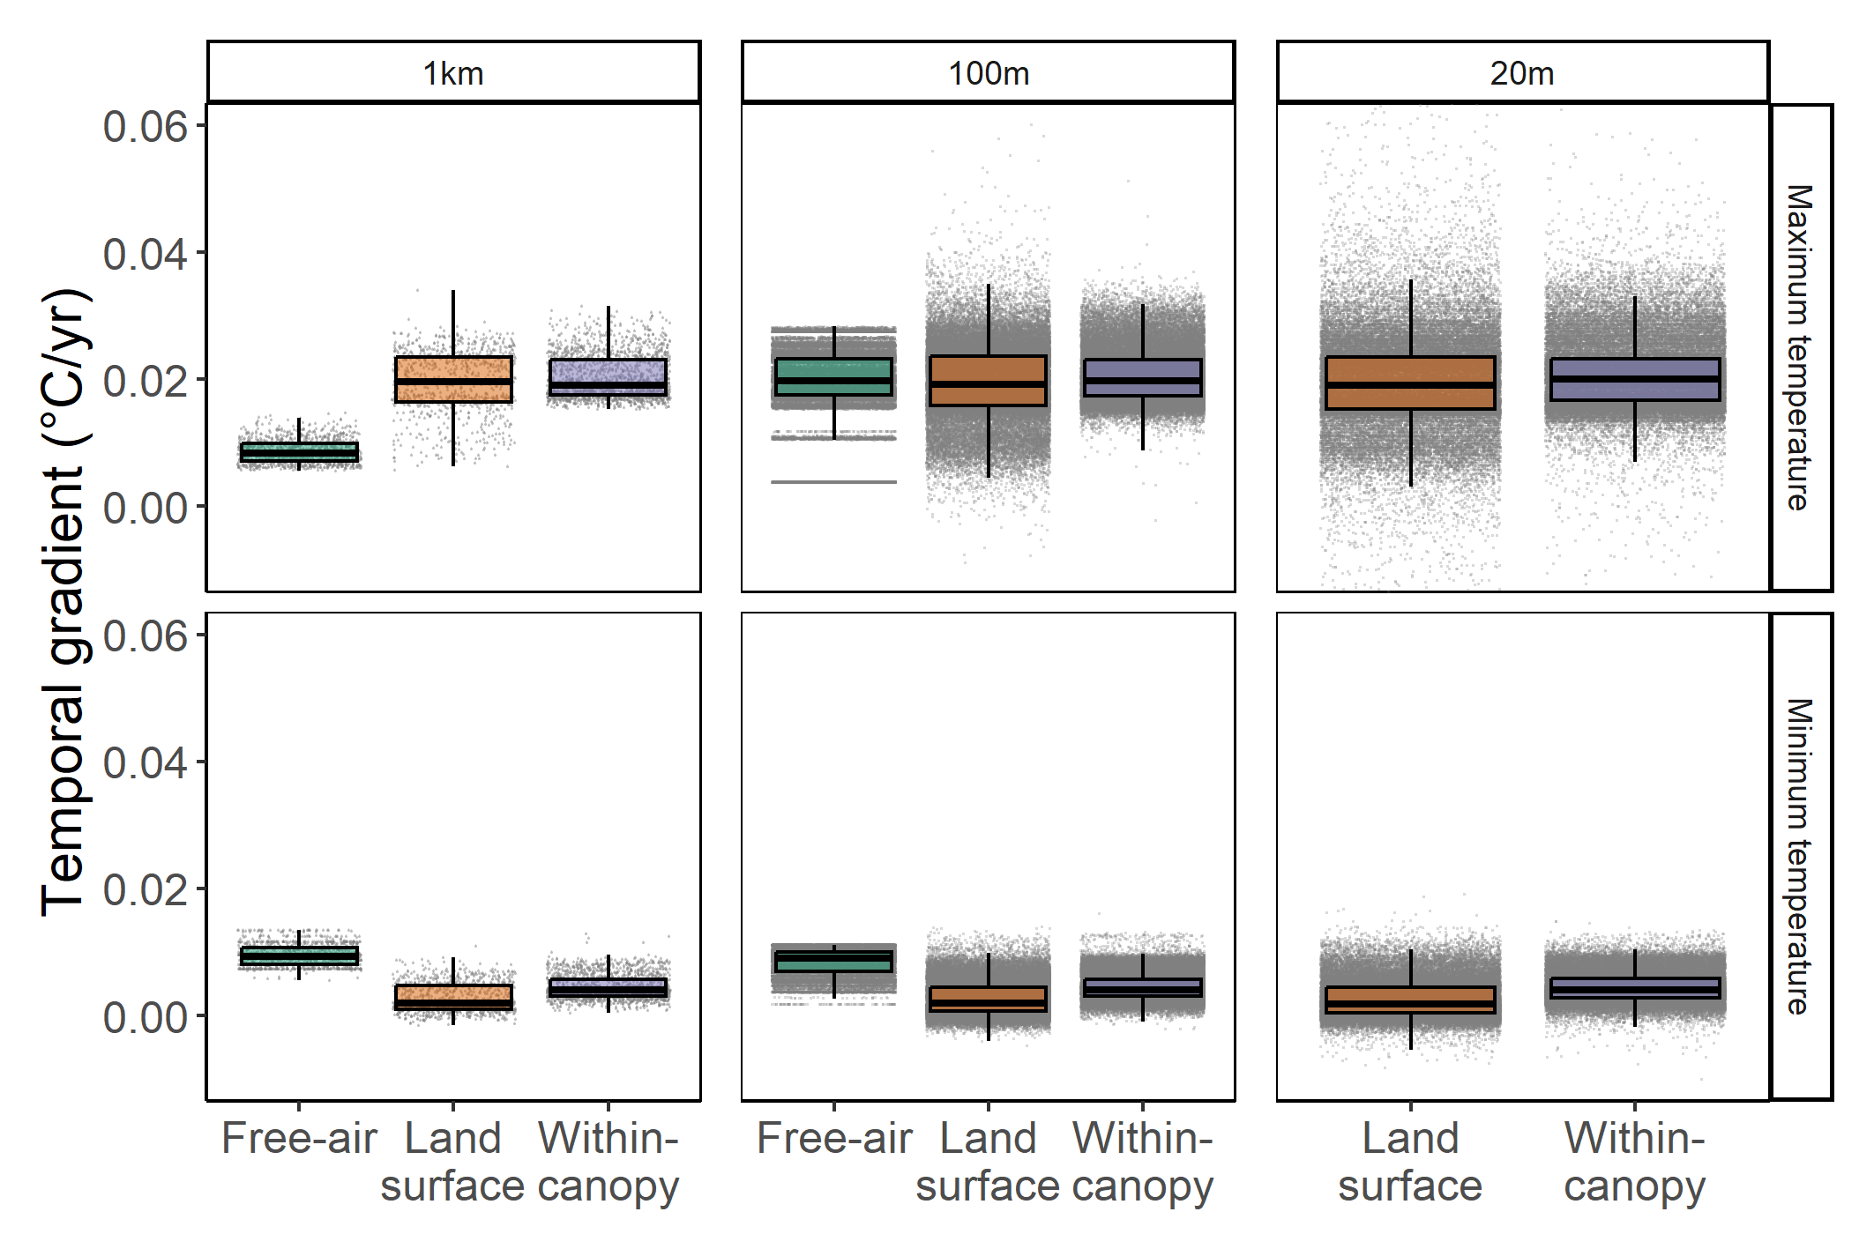

**Extended Data Fig.** **1:** The distribution of the temporal gradient for maximum and minimum temperature velocities (m/yr) in the Northern Range of Trinidad calculated at different spatial scales and using free-air, land-surface, or within-canopy temperatures. Free-air and land-surface velocities are calculated in two dimensions and within-canopy velocities are calculated in three-dimensions. Boxplots display median and 25th and 75th percentiles, with upper and lower whiskers corresponding to 1.5 times the IQR from the 25th or 75th percentiles. Free-air velocities were not calculated at a 20 m resolution. Gray points represent velocities at a maximum of 100,000 randomly selected points within the Northern Range.

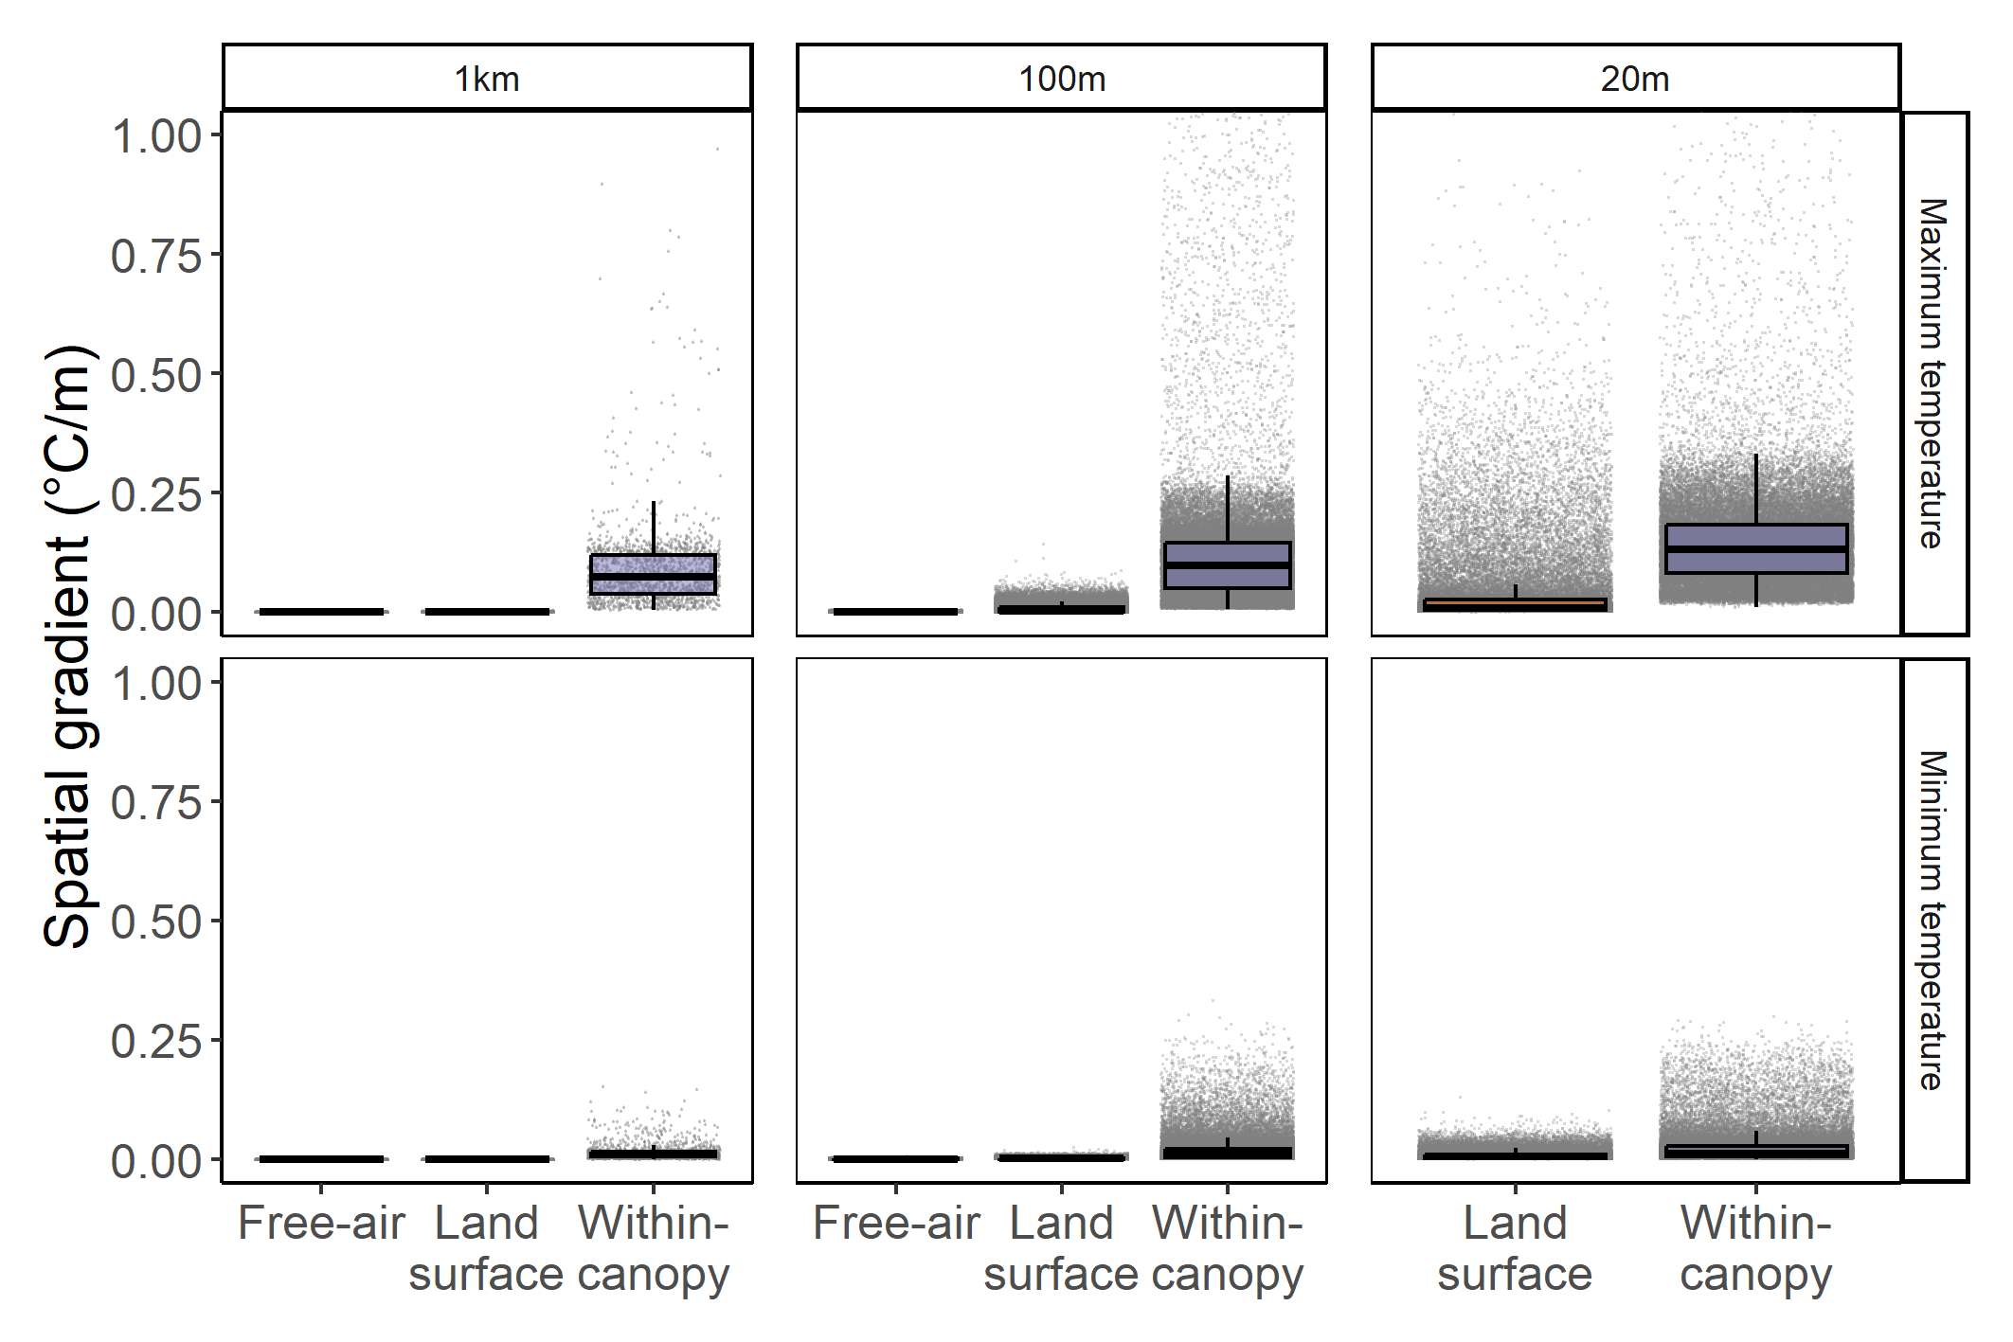

**Extended Data Fig.** **2:** The distribution of the spatial gradient for maximum and minimum temperature velocities (m/yr) in the Northern Range of Trinidad calculated at different spatial scales and using free-air, land-surface, or within-canopy temperatures. Free-air and land-surface velocities are calculated in two dimensions and within-canopy velocities are calculated in three-dimensions. Boxplots display median and 25th and 75th percentiles, with upper and lower whiskers corresponding to 1.5 times the IQR from the 25th or 75th percentiles. Free-air velocities were not calculated at a 20 m resolution. Gray points represent velocities at a maximum of 100,000 randomly selected points within the Northern Range.

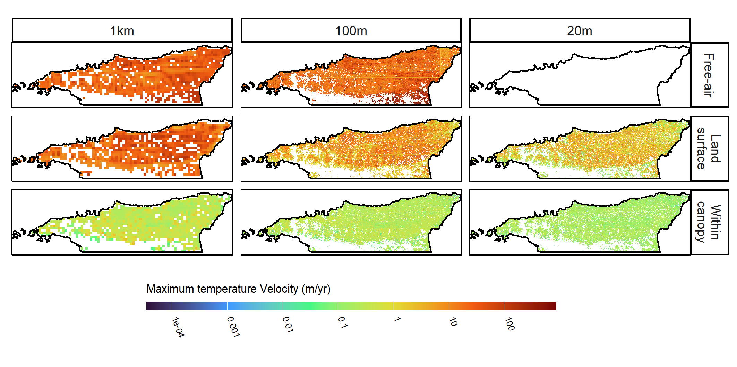

**Extended Data Fig.** **3:** Maps of maximum temperature velocity in the Northern Range of Trinidad at different spatial scales for free-air, land surface, within-canopy conditions.

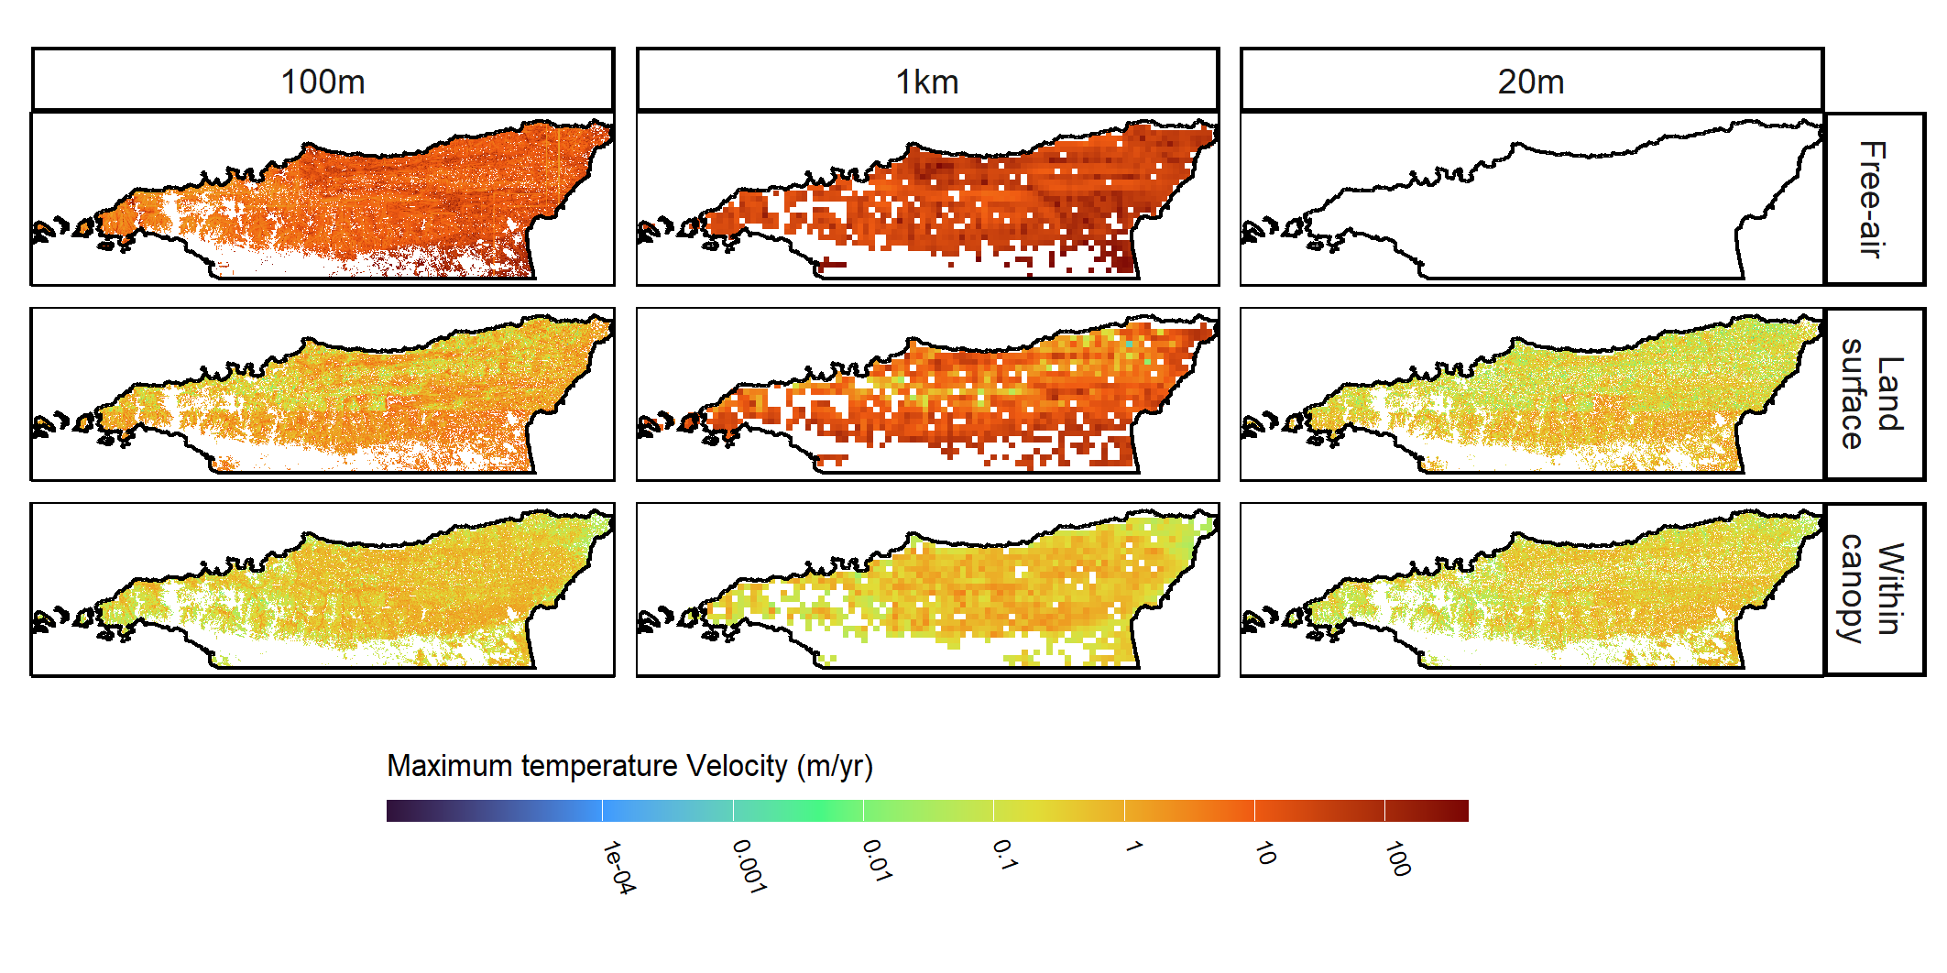

**Extended Data Fig.** **4:** Maps of minimum temperature velocity in the Northern Range of Trinidad at different spatial scales for free-air, land surface, and within-canopy conditions.

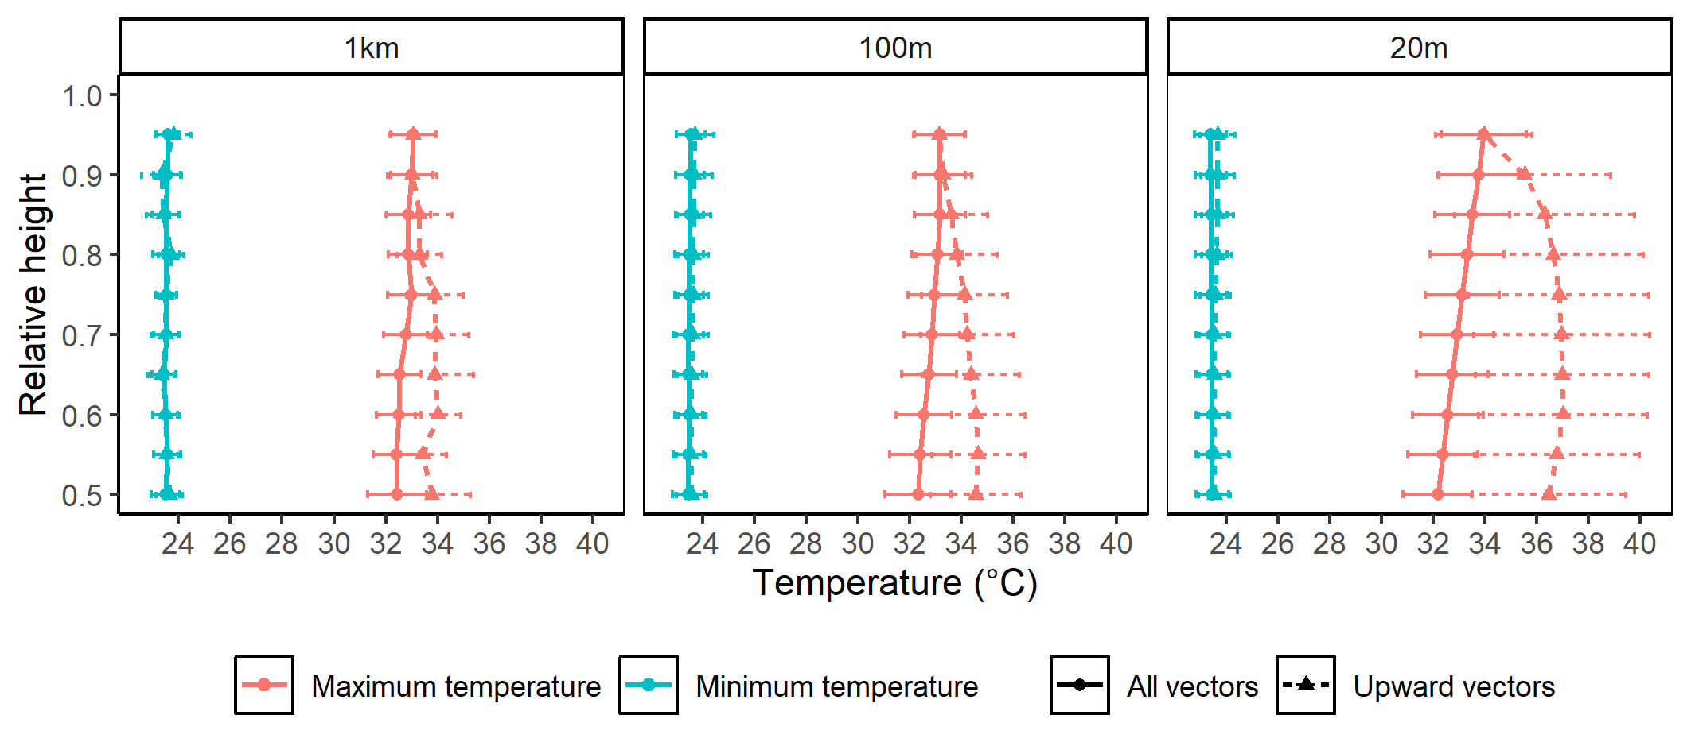

**Extended Data Fig.** **5:** Vertical gradients (mean ± SD) for minimum and maximum temperatures in the Northern Range of Trinidad at different spatial scales. Relative height indicates the absolute height divided by the height of the canopy. Solid lines represent temperature mean and SD of all velocity vectors and dashed lines represent temperature mean and SD of upward directed vectors only.

# Supplementary Tables and Figures

**Table S****1:** Median 2D climate velocities (m/yr), temporal gradients (°C/yr), and spatial gradients (°C/m) for maximum and minimum temperatures in the top quarter of the canopy (canopy) and at 2 m above the ground (land surface).

| Resolution | Variable | Height | Velocity | Temporal gradient | Spatial gradient |
| --- | --- | --- | --- | --- | --- |
| 100m | Maximum temperature | Canopy | 10.763 | 0.020 | 0.002 |
| Land surface | 4.871 | 0.020 | 0.004 |
| Minimum temperature | Canopy | 4.094 | 0.005 | 0.001 |
| Land surface | 1.471 | 0.003 | 0.002 |
| 1km | Maximum temperature | Canopy | 60.865 | 0.020 | 0.000 |
| Land surface | 21.816 | 0.021 | 0.001 |
| Minimum temperature | Canopy | 19.911 | 0.004 | 0.000 |
| Land surface | 12.824 | 0.003 | 0.000 |
| 20m | Maximum temperature | Canopy | 1.636 | 0.020 | 0.012 |
| Land surface | 1.729 | 0.020 | 0.010 |
| Minimum temperature | Canopy | 1.256 | 0.005 | 0.004 |
| Land surface | 0.357 | 0.003 | 0.006 |

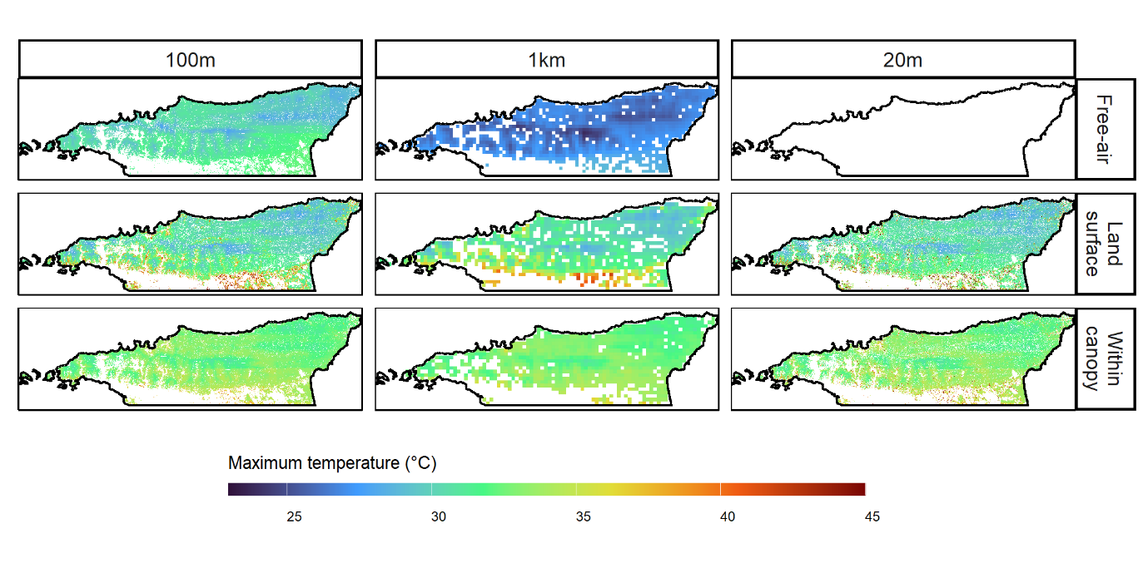

**Fig. S****1:** Maximum temperatures for free-air conditions at 1 km and 100 m resolutions, land surface temperatures at 2 m above the ground and at 1 km, 100 m, and 20 m resolutions, and within-canopy temperatures in the upper half of the canopy (as measured from the ground to the top of the canopy) at 1 km, 100 m, and 20 m spatial resolutions. Temperatures exceeding 45°C are included with the hottest temperatures on the color scale to aid visualization.

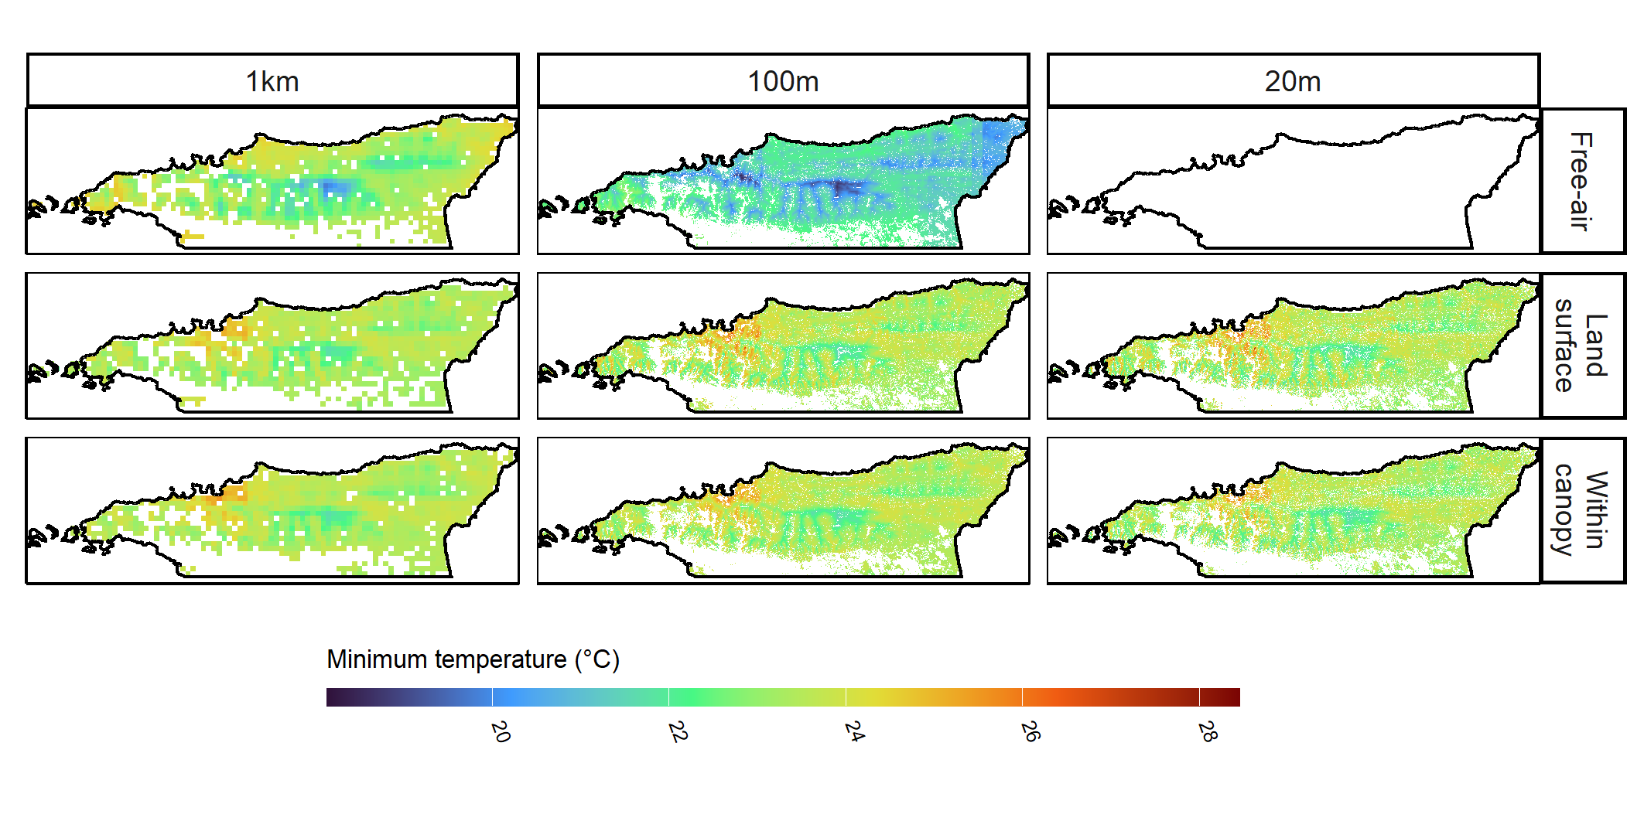

**Fig. S****2:** Minimum temperatures for free-air conditions at 1 km and 100 m resolutions, land surface temperatures at 2 m above the ground and at 1 km, 100 m, and 20 m resolutions, and within-canopy temperatures in the upper half of the canopy (as measured from the ground to the top of the canopy) at 1 km, 100 m, and 20 m spatial resolutions.

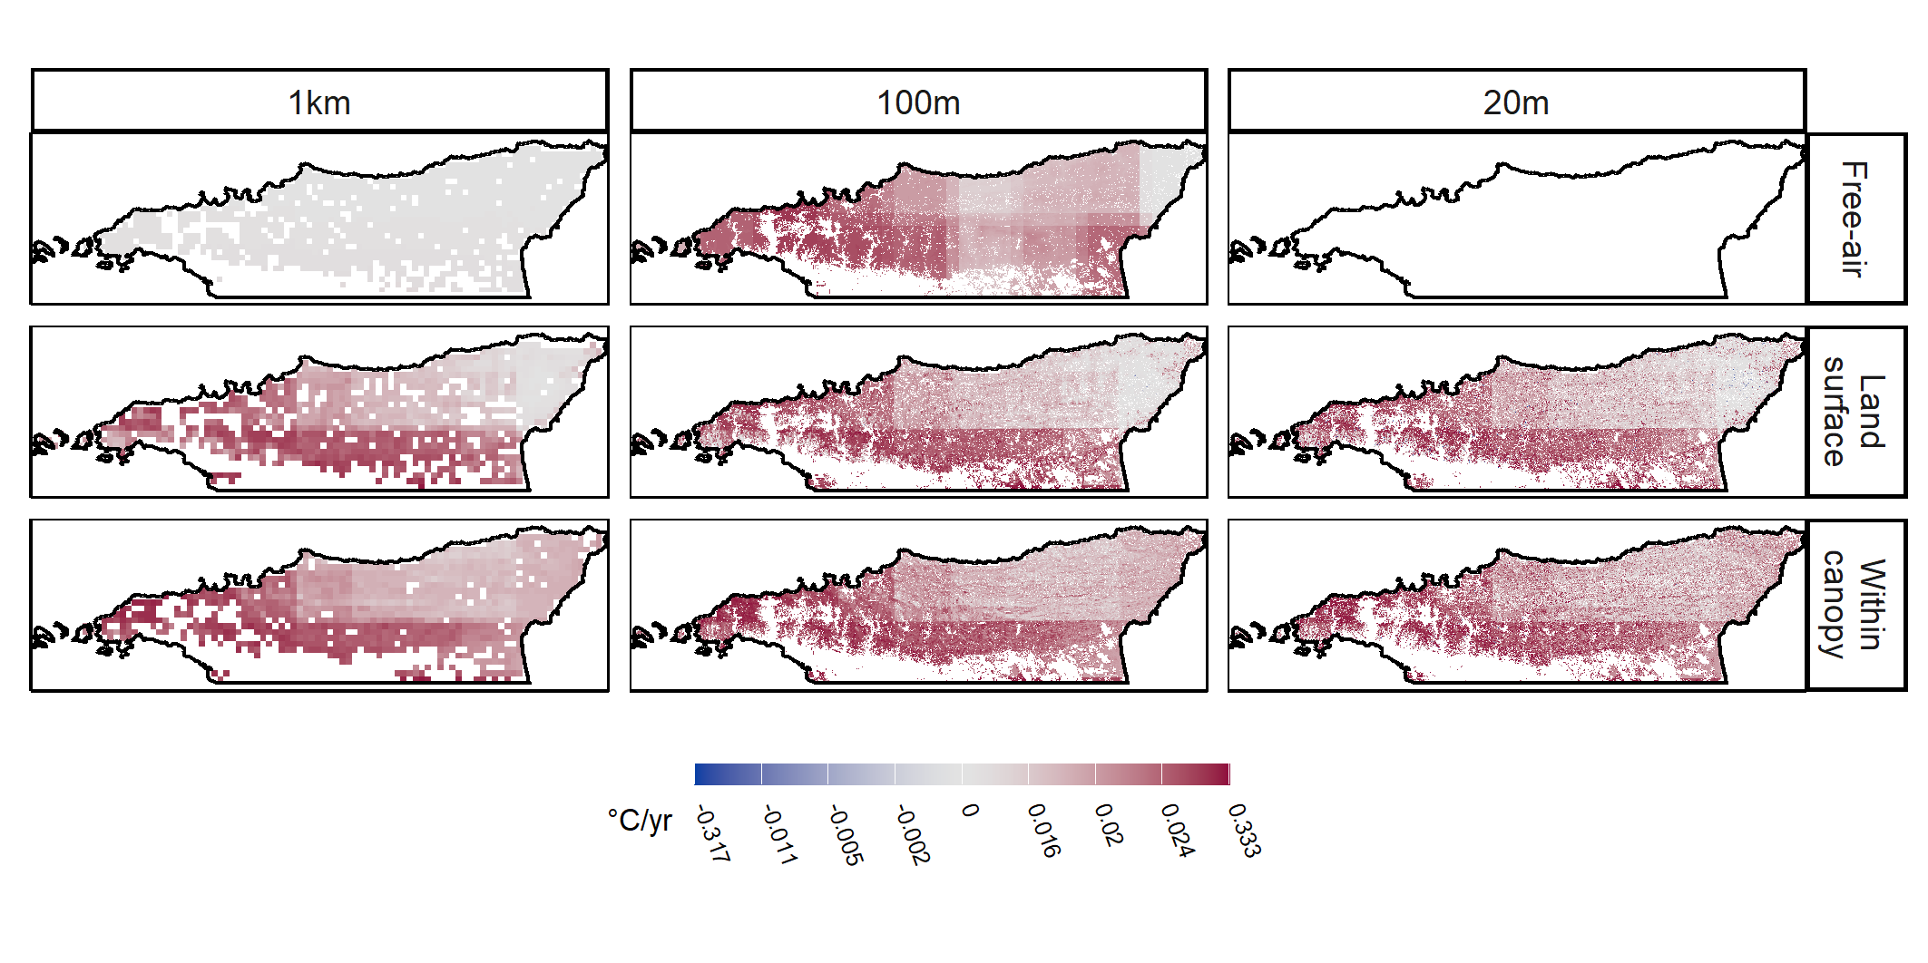

**Fig. S****3:** Temporal gradient of maximum temperature velocity for free-air temperatures, land surface temperatures at 2 m above the ground, and within-canopy temperatures at 1 km, 100 m, and 20 m spatial resolutions.

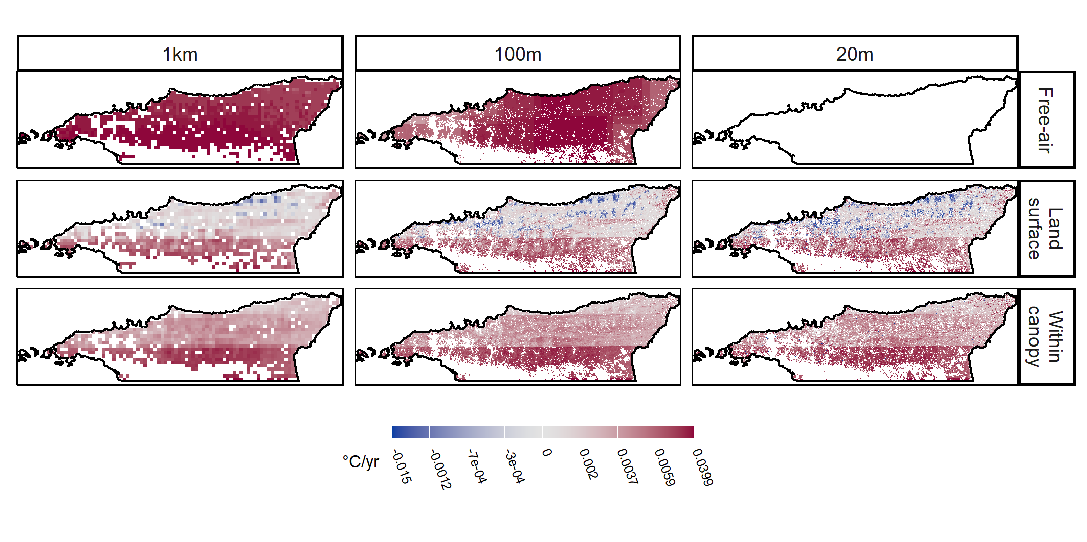

**Fig. S****4:** Temporal gradient of minimum temperature velocity for free-air temperatures, land surface temperatures at 2 m above the ground, and within-canopy temperatures at 1 km, 100 m, and 20 m spatial resolutions.

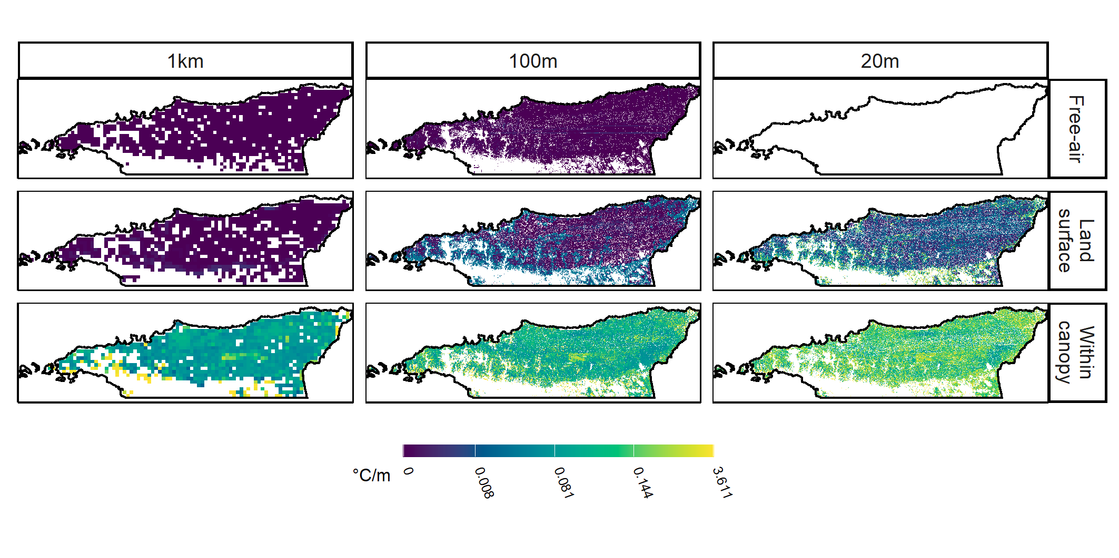

**Fig. S****5:** Spatial gradient of maximum temperature velocity for free-air temperatures, land surface temperatures at 2 m above the ground, and within-canopy temperatures at 1 km, 100 m, and 20 m spatial resolutions.

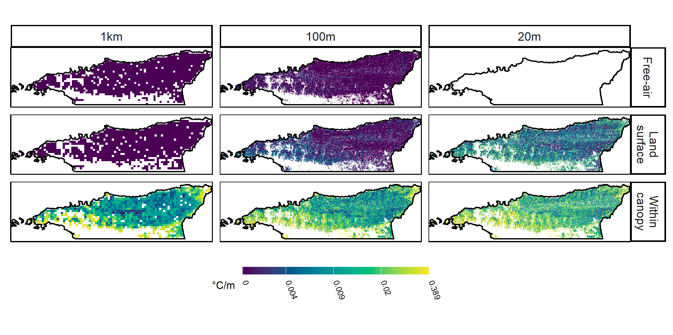

**Fig. S****6:** Spatial gradient of minimum temperature velocity for free-air temperatures, land surface temperatures at 2 m above the ground, and within-canopy temperatures at 1 km, 100 m, and 20 m spatial resolutions.

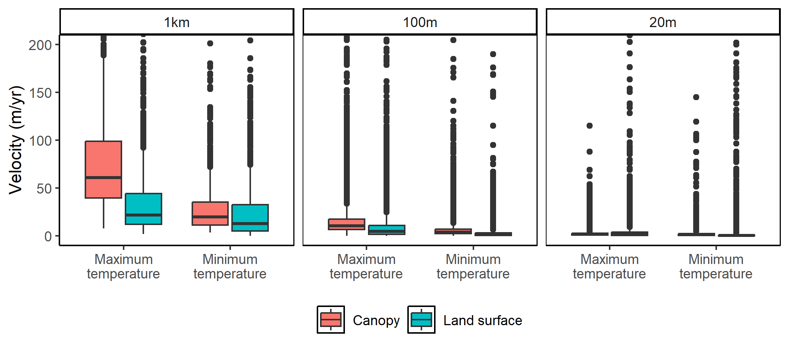

**Fig. S****7:** 2D climate velocities for maximum and minimum temperatures in the top quarter of the canopy (canopy) and 2 m above the ground (land surface) at 1 km, 100 m, and 20 m spatial scales in the Northern Range of Trinidad. Boxplots show medians for up to 10,000 randomly selected points.